Ticket Office Reform

Equality Analysis

Version Number | Update | Updated on
1.0 | Draft complete | 17/07/2023
1.1 | Impact assessment – released in draft | 19/07/2023
1.2 | Impact assessment updated with mitigations | 21/07/2023
1.3 | Impact assessment updated with alt text and restructured mitigations section | 26/07/2023

1. Executive Summary 3

2. Introduction 5

3. Northern Policies Relevant to Protected Groups 8

3.1 Customer Policies 8

4. Proposed Ticket Office Reform 10

4.1 Project Overview 10

4.2 Retail Channels 11

4.3 Journey Makers 12

4.4 Safety and Security 14

4.5 Accessibility 14

5. Methodology 15

6. Evidence Considered 17

6.1 Mapping Affected Stations to their Boroughs 17

6.2 Demographic and socio-economic data 22

6.3 Our Data 42

6.4 Engagement and Consultation 46

7. Potential Impacts 48

7.1 Potential positive impacts on all protected characteristics 49

7.2 Potential negative impacts on all protected characteristics 49

7.3 Equality Impact Summary 51

7.4 Age 52

7.5 Disability 54

7.6 Gender reassignment 59

7.7 Marriage and Civil Partnership 61

7.8 Race 62

7.9 Pregnancy & Maternity 64

7.10 Religion or Belief 65

7.11 Sex 68

7.12 Sexual Orientation 70

8. Case Studies 71

8.1 Hexham Station 73

8.2 Harrogate Station 76

8.3 Manchester Victoria Station 80

8.4 Meadowhall Station 83

9. Summary of Analysis 88

10. Mitigation approach 91

Appendix A - General Improvement Mitigations 94

Appendix B – Station to Protected Characteristic Mapping 99

B.1 Affected Protected Characteristics 99

B.2 Index of Multiple Deprivation 99

B.3 Step Free Access 99

B.4 Station to Protected Characteristics mapping output 101

Appendix C - Station Mitigation Dashboards 114

C.1 Mitigation Categories 114

C.2 Station Dashboard Files 115

Appendix D - Station Ticket Office Closure Mitigations – Further explanation 121

Annex A: Data sources 128

Annex B: Breakdown of police force areas 130

1. Executive Summary

Northern has undertaken an equality analysis on the proposed Ticket Office Reform project.
This equality analysis aims to explore the potential positive and negative impacts on individuals who share protected characteristics. This equality analysis will help to make sure that Northern integrates equality considerations into the project’s decision-making process and continues to promote inclusive policies, activities, and procedures.
An equality analysis is also a means by which Northern can demonstrate how we are complying with our statutory duties under the Equality Act 2010 to have due regard to the impact of our services on individuals with protected characteristics.
The structure of the document is as follows:
- We first provide an overview of Northern’s policies that relate to certain protected characteristics in Section 3.
- We then provide an overview of the Ticket Office Reform project in Section 4.
- We discuss our methodology for conducting this equality analysis in Section 5.
- We outline the evidence and data that were considered for this equality analysis in Section 6.
- Through the analysis, we have identified potential positive and negative impacts on individuals who share protected characteristics. These impacts are discussed in Section 7.
- To provide further illustrations of the impacts on customers, we interviewed individuals at four stations – these case studies are discussed in Section 8.
- We then provide a summary of the impacts as they pertain to the three aims of the Public Sector Equality Duty in Section 9.
- Section 10 sets out our approach to mitigating the impacts identified in the equality analysis.
- Appendix A sets out general mitigations which cover a wide range of Northern’s existing and proposed customer offerings but are not specific solely to the proposed changes to ticket offices.
- Appendix B sets out the protected characteristics which are negatively or positively impacted as a result of the proposed changes
- Appendix C sets out station-specific mitigations to the impacts identified in the equality analysis (supported by additional documentation)
- Appendix D provides a more detailed explanation of the mitigation and rationale which support it.

2. Introduction

This document provides an overview of the equality impacts of Northern’s Ticket Office Reform project. The key reforms proposed through this project include closing Ticket Offices (Ticket Offices) at 131 stations, making changes to operating hours at 18 remaining Ticket Offices, and reallocating a proportion of Ticket Office colleagues to a new customer-facing role (called a ‘Journey Maker’) within stations.
The nine protected characteristics specified in the Equality Act 2010 are:
- Age: Refers to a person belonging to a particular age (for example 25 years old) or range of ages (for example 18-30 years old).
- Disability: Refers to a person who has a disability (physical or mental impairment), which has a substantial and long-term adverse effect on that person’s ability to carry out normal day-to-day activities.
- Gender reassignment: Refers to a person who is proposing to undergo, is undergoing, or has undergone a process (or part of a process) for the purpose of reassigning the person's sex by changing physiological or other attributes of sex.
- Marriage and civil partnership: Refers to a person who is married or is a civil partner to either the person of same sex or opposite sex. Civil partners must not be treated less favourably than married couples (except where permitted by the Equality Act).
- Race: Refers to a group of people defined by their race, colour; nationality (including citizenship); and ethnic or national origins.
- Pregnancy and Maternity: Pregnancy is the condition of being pregnant or expecting a baby. Maternity refers to the period after the birth and is linked to maternity leave in the employment context. In the non-work context, protection against maternity discrimination is for 26 weeks after giving birth, and this includes treating a woman unfavourably because she is breastfeeding.
- Religion or belief: Religion refers to any religion, including a lack of religion. Belief refers to any religious or philosophical belief and includes a lack of belief.
- Sex: Refers to a particular protected characteristic of being a man or a woman.
- Sexual orientation: Refers to a person's sexual orientation towards persons of the same sex; persons of the opposite sex, or a person of either sex.

As set out in section 149 of the Equality Act 2010, we are required to have due regard to the following when exercising our functions:
- Eliminate discrimination, harassment, victimisation, and any other conduct that is prohibited by or under the Act.
- Advance equality of opportunity between persons who share a relevant protected characteristic and persons who do not share it.
- Foster good relations between persons who share a relevant protected characteristic and persons who do not share it.
To ‘advance equality of opportunity between persons who share a relevant protected characteristic and persons who do not share it’, there is a particular need to:​
- Remove or minimise disadvantages suffered by people due to their protected characteristics.
- Take steps to meet the needs of people from protected groups where these are different from the needs of other people.
- Encourage people from protected groups to participate in public life or in other activities where their participation is disproportionately low.​
About Northern
Northern Trains (operating as Northern) is owned by Northern Trains Limited, a subsidiary of the Department for Transport’s public sector owning group, DfT OLR Holdings Limited (DOHL). DOHL’s other subsidiaries include Transpennine Express (TPE), London North Eastern Railway (LNER), and Southeastern (SE) trains. Of these, Northern is the largest passenger train operator. Our trains call at nearly 550 stations, 467 of which we manage.
Northern is split into four regions – Central, East, North East, and West – which are further broken down into ten service groups:
- Tyne, Tees & Wear  - Lancashire & Cumbria Local  - West & North Yorkshire Inter Urban  - West & North Yorkshire Local  - South & East Yorkshire Inter Urban | - South & East Yorkshire  - North Manchester  - Merseyrail City Lines  - South Manchester  - Lancashire & Cumbria Inter Urban

3. Northern Policies Relevant to Protected Groups

3.1 Customer Policies

Northern has committed to provide accessible rail services to all customers and to support the communities in which we operate. Emphasis is placed on enabling older and disabled passengers to travel with confidence. The provision of services to these customers is embedded in business and project planning, and training is offered to employees to ensure they have the right resources, skills, and confidence to deliver appropriate assistance. We also regularly review and evaluate the impact of our Accessible Travel Policies. Key offerings for older and disabled customers include:
- Assistance at stations and on trains, including when making connections.
- Alternative accessible transport in case of inaccessibility at stations or on trains.
- Clear, consistent, and up-to-date customer information (in both aural and visual form, shared through ‘Making rail accessible’ leaflet, Customer Experience centre, Ticket Offices, public address systems on trains and website).
- A range of discounts to reduce the cost of travel for disabled people and their companion, alongside the disabled person’s railcard and senior railcard.
Other accessibility services and initiatives relevant to the equality analysis include:
- Passenger Assist Facility: Northern provides access to an industry-wide booking assistance platform called Passenger Assist. Customers can use the system at any time to book assistance at stations during their journey and they can also book assistance to board and alight trains.
- Northern Mobility Scooter Permit: The Mobility Scooter Permit scheme accommodates certain types on mobility scooters on trains. Currently, the scheme is applicable for journeys on 28 specified routes and over 160 stations where scooters can safely move throughout the station. Northern is committed to expand ‘mobility scooter friendly’ stations.
- Priority Seating card: The Priority Seating card enables customers with visible and invisible disabilities to feel confident and empowered when asking other customers to offer them priority seats. The card is available free of charge and has unique branding for easy recognition. Customers can personalise their cards by writing out their specific requirements.
- Other facilities and support: Please see Appendix C for a full list of facilities relevant to the equality analysis at each station (available and planned). Northern provide detail of all current station facilities on their station pages
- Accessibility and Inclusivity for All (AlfA): We are improving our stations and the experience of customers and our people through the Accessibility and Inclusivity for All (AIfA) programmes. Depending upon station survey results (e.g., existing facilities / condition), the following will either be renewed or a new asset installed.
- PA induction loops
- Help points
- Station maps
- Braille maps
- Station signage / wayfinding
- Existing toilet upgrade
- New POD install
- Handrails repair / paint
- Stair nosings and tactiles – repair / paint
- Seating – repair / paint / replace
- Shelters – repair / paint / replace
- Drop off shelters
- Car park works, repair and reline
- Door mats – repair / replace
- Replace cycle shelter
- Footpath / drop kerb improvements / ramps
- Platform overlays (reducing the distance between the platform and the train)

4. Proposed Ticket Office Reform

4.1 Project Overview

The need for change
Across many areas of life, the way people access services and buy products has changed. Northern customers are no different and we need to modernise to respond to their changing needs.
As customer habits have changed, people have moved to other, more convenient ways of buying tickets. Many people prefer to buy online or use apps, a trend that is expected to continue.
- Nationally just 12% of ticket transactions sales are made through a ticket office.
- Only 1 in 6 journeys on Northern services are bought through a ticket office, compared with almost half of all journeys in 2018.
As the railway adapts to evolving customer behaviour and to ensure that it can thrive in the long-term, we need to modernise how tickets are sold.

Our commitment to customers and communities
We connect tens of thousands of people with work, leisure, education and more. And we have a long-term vision for the future, with customers and communities at the very heart of what we do.
We know that stations will play an important part of our vision, which is why we will make sure that they better serve all our customers as well as the local communities that live around them.
- Manage 467 stations – 18% of stations in the UK.
- Operate ticket offices at 149 stations.
- 318 stations already operate without ticket offices.
We need to provide value for customers and communities we serve and make sure the railway is sustainable. This comes with a real opportunity to transform our stations.

We are committed to making sure our train services are accessible to everyone so customers can travel with confidence.
As part of our proposals:
- Station opening times will not change and our train services are unaffected.
- All our train services will continue to support accessible travel.

Changes to ticket offices
We manage 467 stations and 318 of these operate without ticket offices. Our proposals mean that ticket offices at a further 131 stations will close. We will also reduce the number of hours that Northern colleagues are present at these stations.
We plan to close our ticket offices in phases over an 18-month period, subject to the outcome of this consultation, commencing in early 2024.
We will keep ticket offices at the 18 stations listed below. Ticket offices at these stations will have amended ticket office opening times and the number of hours that Northern colleagues are present at these locations will reduce. These ticket offices have been chosen based on location and volume of ticket sales.
- Barrow-in-Furness
- Blackburn
- Blackpool North
- Bolton
- Bradford Interchange
- Glossop
- Harrogate
- Hartlepool
- Leeds
- Liverpool Lime Street
- Manchester Oxford Road
- Manchester Victoria
- Rochdale
- Salford Crescent
- Skipton
- St Helen’s Central
- Warrington Central
- Wigan Wallgate

4.2 Retail Channels

At the point at which Northern closes the proposed tickets offices, the full range of our products which currently retail in ticket offices will be available digitally. Northern also expects that the majority of customer retail transactions will transition to alternative channels. This would be in line with patterns of customer behaviour that is already observed across all stations. Customers will be supported by ‘Journey Makers’ and will have access to the following retail options:
- 18 Ticket Offices: Northern will retain 18 Ticket Offices at key locations (based on geography and footfall) that will continue to retail the full range of ticket products that they do currently (in cash and cashless methods).
- Ticket Vending Machine (TVMs): A comprehensive network of TVMs already offer customers an alternative to using a Ticket Office. All locations where the Ticket Office will close have at least one TVM in place. Northern has reviewed the current and forecasted demand for TVMs and have concluded that they have sufficient capacity to accommodate additional transactions arising from Ticket Office closures. There are plans to enhance the support the TVM can offer customers. For example, there are plans for all TVMs to have Video Assistance capability which allows a remote colleague to take over the ticket buying process for the customer up to the point of payment, as well as supporting customers with journey planning and ticketing information.
- Online purchasing: The majority of the ticket types that Northern retail are available for purchase online, for example on the Northern App or on National Rail Enquiries. We will look to support customers with the use of online purchasing via our on-station through multiple customer service channels.
- On train: Cash paying customers will be able to continue to use cash for all Journeys by buying a ticket onboard from the conductor, providing they get a ‘Promise to Pay’ ticket at a TVM before they board.
- Local retail outlets: Customers will also soon be able to purchase tickets using cash and card from a new channel at 'ticket stops' at local retail outlets. This service will be implemented at approximately 4,000 retail locations. It will allow customers to purchase physical tickets from varied locations outside of the stations at their convenience.

4.3 Journey Makers

Our colleagues will continue to provide a great service for our customers. As part of our proposed changes to ticket offices, we will be removing all existing ticket office roles. Instead, we will bring our ticket office colleagues into new Journey Maker roles to help customers around the station.
Journey Makers will be based at stations, although no longer within ticket offices. They’ll be available in other areas of the station to help customers face to face with a wide range of needs. This includes supporting people who need extra help travelling through our stations and onto trains.
Journey Makers will support customers by:
- Giving customers information
- Helping customers to buy tickets online and via machines
- Keep stations clean and tidy
- Make announcements at stations
- Provide extra assistance to those who needs it
- Assist during service disruption
- Help resolve customer issues
- Sell tickets at ticket offices
All 149 stations where we have ticket offices currently will continue to have a colleague presence.
Colleagues who will remain in station-based roles will receive appropriate training. This will include disability awareness course and passenger assistance training.

4.4 Safety and Security

The safety and security of customers and colleagues are priority areas for Northern in the implementation of station reform.
Northern consider that increased visibility of the colleagues (in the form of a Journey Maker) around the station environment will provide customers with an increased assurance around their safety and security. For safety purposes, all Journey Markers will also be equipped with a body-worn camera and local microphone which provides additional safety and security assurance. Help points will be available at many stations to enable customers to speak to a Northern colleague within the contact centre if no colleagues are available at the station.
For full detail of our current and future safety mitigations please refer to the appendices.

4.5 Accessibility

Northern will ensure that customers currently requiring assistance for boarding and alighting train services will continue to receive support from on-board colleagues in line with Northern’s Accessible Travel Policy.
For full detail of our current and future accessibility mitigations please refer to the Appendix A, C and D.

5. Methodology

This equality analysis aims to identify any potential positive and negative impacts resulting from the reforms proposed in the Station Retailing and Multi-Skilling project. To identify what these impacts are likely to be and where they are most likely to occur, each of the 149 affected stations (i.e., 131 stations to be closed and 18 stations facing changes) were mapped into their respective boroughs (42 in total) and overlayed with publicly available demographic data on each of the protected characteristics. Socio-economic data on each of the ‘affected boroughs’ – including employment rate, index of multiple deprivation (IMD) score, gender pay gap, crime rate and commuting patterns – have also been incorporated.
Furthermore, for each of the affected stations we have set out in the appendices the existing and planned mitigations for negatively impacted protected characteristic that have been identified through the analysis.
Comparisons have been made between the affected boroughs and England as a whole, allowing Northern to assess which protected characteristic groups and individual stations could be impacted disproportionately by the reforms, both positively and negatively. To support and contextualise the findings from our quantitative analysis, insights from our literature review, covering a wide range of government, industry and academic literature, are included.
A table summarising the likely impacts on each of the protected characteristics (across all stations) is found in Section 7. In Appendix B, an impact assessment (positive or negative) has been applied to all 149 of the affected stations to illustrate whether the removal of the Ticket Offices will have positive and / or negative impacts against each protected characteristic. An index of Multiple Deprivation (IMD) has also been applied to each station
Data limitations
There are some limitations to the data used for this equality analysis.
- Demographic data: The demographic data used in this analysis comes from the UK Office for National Statistics (ONS) and the Ministry of Housing, Communities & Local Government. All data sources used are listed in Annex A: Data sources. Where Census data is used, it has been taken from the 2021 Census, and where necessary, 2020 ONS data was used where 2021 Census data was not available. Due to the various datasets, numbers may not exactly match and are instead used to give a high-level indication of demographic trends. In some datasets, no data was available for the boroughs of Cumbria (Westmoreland and Furness and Cumberland) and North Yorkshire (Harrogate, Craven, Richmondshire, Selby, Hambleton, Ryedale, and Scarborough) at a more granular level and data at this level was used as a proxy. In most instances, data for Cumbria was not available.
- Northern’s data: In some instances, granular data on protected characteristics, such as disability and religion, was not available.

6. Evidence Considered

6.1 Mapping Affected Stations to their Boroughs

Northern splits its network into four regions: Central, East, North East, and West. The 149 stations affected by the Ticket Office Reform project span 42 local authority districts, which we refer to in this report as ‘affected boroughs’. The equality analysis does not assess Northern’s complete network.
Figure 1: Map of all affected stations by region
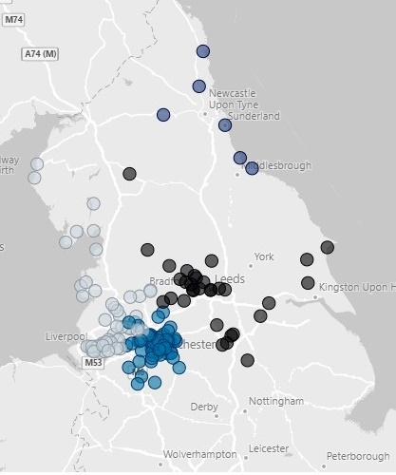

Figure 2: Affected boroughs by population size (with red being the largest population, and green the smallest)
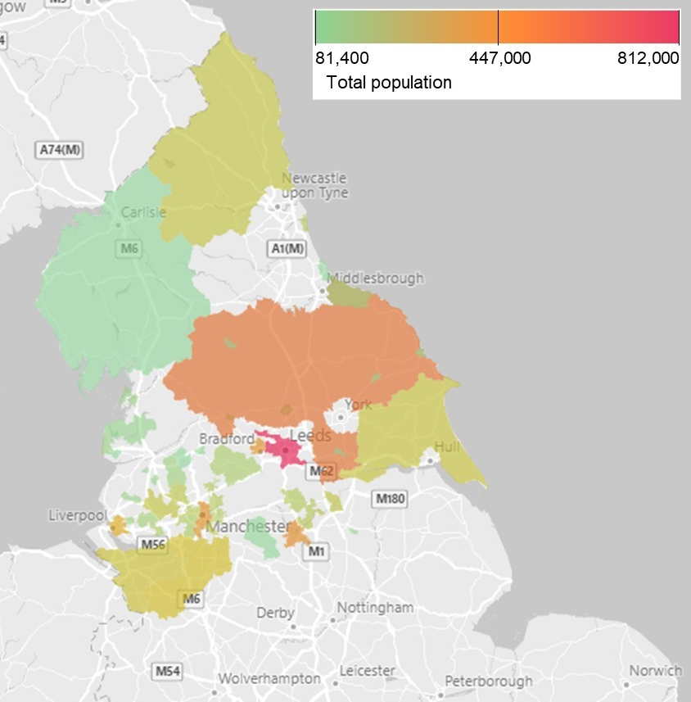
Table 1: Number of affected stations in each borough
Affected Borough | No of Stations | Affected Station(s) name
Barnsley | 1 | Barnsley
Bassetlaw | 1 | Worksop
Blackburn with Darwen | 1 | Blackburn
Blackpool | 1 | Blackpool North
Bolton | 5 | Bromley Cross  Daisy Hill  Farnworth  Lostock Parkway  Bolton
Bradford | 7 | Bingley  Ilkley  Menston  Bradford Forster Square  Keighley  Shipley  Bradford Interchange
Burnley | 2 | Burnley Central  Burnley Manchester Road
Calderdale | 3 | Hebden Bridge  Todmorden  Halifax
Cheshire East | 9 | Alderley Edge  Congleton  Disley  Handforth  Holmes Chapel  Knutsford  Poynton  Sandbach  Wilmslow
Cheshire West and Chester | 1 | Northwich
Chorley | 3 | Adlington (Lancashire)  Buckshaw Pathway  Chorley
Cumbria (Westmoreland and Furness, and Cumberland) | 7 | Grange-Over-Sands  Windermere  Whitehaven  Appleby  Ulverston  Barrow-In-Furness  Workington
Doncaster | 2 | Mexborough  Thorne North
East Riding of Yorkshire | 4 | Beverley  Driffield  Goole  Bridlington
Fylde | 2 | Kirkham & Wesham  St Annes-On-The-Sea
Halton | 2 | Hough Green  Widnes
Hartlepool | 1 | Hartlepool
High Peak | 7 | Dinting  Hadfield  New Mills Central  New Mills Newtown  Whaley Bridge  Glossop  Buxton
Hyndburn | 1 | Accrington
Knowsley | 5 | Halewood  Huyton  Prescot  Roby  Whiston
Lancaster | 1 | Morecambe
Leeds | 6 and 1 Travel Centre | Cross Gates Yorks  Garforth  Guiseley  Horsforth  New Pudsey  Leeds  Leeds Travel Centre
Liverpool | 6 | Broad Green  Edge Hill Liverpool  Mossley Hill  Wavertree Technology Park  West Allerton  Liverpool Lime Street
Manchester | 8 | Burnage  East Didsbury  Gorton  Levenshulme  Mauldeth Road  Deansgate  Manchester Oxford Road  Manchester Victoria
North Yorkshire (Craven, Hambleton, Harrogate, Richmondshire, Ryedale, Scarborough, and Selby) | 3 | Settle  Harrogate  Skipton
Northumberland | 3 | Hexham  Morpeth  Alnmouth
Oldham | 1 | Greenfield
Redcar and Cleveland | 1 | Redcar Central
Rochdale | 2 | Littleborough  Rochdale
Rotherham | 2 | Swinton (Yorks)  Rotherham Central
Salford | 5 | Eccles  Swinton (Greater Manchester)  Walkden  Salford Central  Salford Crescent
Sheffield | 1 | Meadowhall
South Ribble | 1 | Leyland
St. Helens | 9 | Earlestown  Eccleston Park  Garswood  Lea Green  Newton-Le-Willows  Rainhill  St Helens Junction  Thatto Heath  St Helens Central
Stockport | 14 | Bramhall  Bredbury  Brinnington  Davenport  Gatley  Heaton Chapel  Marple  Reddish North  Romiley  Rose Hill (Marple)  Woodsmoor  Cheadle Hulme  Hazel Grove  Heald Green
Sunderland | 1 | Sunderland
Tameside | 6 | Ashton-Under-Lyne  Broadbottom  Hattersley  Mossley (Manchester)  Newton For Hyde  Guide Bridge
Trafford | 4 | Chassen Road  Flixton  Hale  Urmston
Warrington | 4 | Glazebrook  Warrington West  Birchwood  Warrington Central
West Lancashire | 1 | Parbold
Wigan | 4 | Atherton  Hag Fold  Hindley  Wigan Wallgate
Wyre | 1 | Poulton-Le-Fylde
Total: 42 Boroughs, 149 stations and 1 Travel Centre

6.2 Demographic and socio-economic data

In this section, publicly available demographic and socio-economic data is used to draw comparisons between the affected boroughs and England as a whole. This analysis shows that the demographic and economic trends seen in the affected boroughs are generally representative of the rest of England, with a few minor exceptions.
Additional statistics and insights from government, industry and academic research have also been incorporated where relevant to contextualise the travel-related issues and challenges faced by customers – dependent on their shared protected characteristics. For example, some customers may face mobility-related challenges due to their protected characteristic. Furthermore, we have included general context via a literature review in which the Northern colleagues are likely to be operating in. The external literature review is particularly relevant in the absence of customer data. Together, this information was used to inform our impacts section (see 7. Potential Impacts), where potential positive and negative impacts of the policy are discussed.
Although each protected characteristic is examined individually, we recognise the intersectional issues that pertain to individuals as a result of having multiple social identities, such as gender, class, sexuality, and race (e.g., an ethnic minority cisgender woman). We recognise that different individuals will have intersecting or overlapping identities, which may pre-dispose them to varying experiences of discrimination and privilege.
The affected boroughs account for nearly 20% of the population in England (see Table 2). Across the North West, North East and Yorkshire and The Humber, the population has increased by 10.8% since 2011, compared to 6.5% across England as a whole. As of 2021, Leeds has the highest population of the affected boroughs (812,000 people). The affected stations with the highest borough populations are located in the North East and Eastern regions, such as North Yorkshire.
Table 2: Population Summary. Census 2021.
 | Affected Boroughs | England
Total population | 10,678,100 | 56,489,800

6.2.1 Age
Demographics: The UK has a growing and aging population, “with more people than ever before in the older age groups.” It is projected that by mid-2045, England’s elderly population will have doubled, in part due to increasing life expectancies. Table 3 breaks down age groups in the affected boroughs and compares this to national figures. The proportion of children in boroughs with affected stations is consistent with national figures. The proportion of adults in the affected boroughs is marginally lower by 0.5%, and the elderly population is slightly higher by 0.4%. It is anticipated, therefore, that the number of over 65s in the affected boroughs will increase.
Table 3: Breakdown of population by age, affected boroughs and England. Census 2021.
Age Group | % of population in Affected Boroughs | % of population in England
Children (<15 years) | 17.5% | 17.4%
Adults (16-64 years) | 63.7% | 64.2%
Elderly (65+ years) | 18.8% | 18.4%

Customer considerations: A study by the Department for Education found that 81% of young people find it easy to access information about public transport times in their area, while 92% feel confident using public transport. The majority of young people report that they feel safe using public transport in their area.
Conversely, older people are more likely to experience mobility deprivation due to physical restrictions, such as physical ailments, the design of the built environment (e.g., no step-free access) and high prevalence of disability as people age. Older people are also more likely to experience a decline in psychological well-being and reduced income (e.g., reliance on pensions). As women and those of white ethnicity typically live longer due to gender and ethnic health disparities, they are likely to have a higher representation in the elderly demographic group.
As people age, they generally decrease their car usage and rely on public transport. Public transport plays an important role for older people, particularly in tackling social exclusion and maintaining wellbeing. However, older people may struggle to use public transport due to difficulties with mobility, barriers associated with their health, inconvenience (whether due to lack of information about local transport routes or in people’s perception of public transport), and if transport does not go where they want it to go (i.e., the end-to-end journey). The impact of the increasing digital divide should also be considered: elderly customers may have difficulties or lack confidence utilising new technologies (e.g., ticket vending machines or mobile apps) to purchase tickets due to lack of digital literacy skills or access to devices. Moreover, cash as the preferred payment method remains the most popular with the elderly (specifically, those aged 65+).

6.2.2 Disability
Demographics: Table 4 breaks down the proportion of people within the affected boroughs who identified as disabled in the 2021 Census. The Census considers a person disabled under the Equality Act if their day-to-day activities are limited in any way (either ‘a lot’ or ‘a little’). If a person has no long-term physical or mental health condition, or if these conditions do not limit day-to-day activities, they are not considered disabled. Disability can include visible disabilities, such as the need for physical aids such as a wheelchair, or less visible disabilities such as cognitive or sensory impairments.
The proportion of people with disabilities in the affected boroughs (19.2%) is 1.5% greater than the national average (17.7%). In England, 18.7% of females and 16.5% of males are disabled. The North of England has the largest proportion of disabled people in England, specifically the North East (21.2%), the North West (19.8%) and Yorkshire, and the Humber (18.9%). The prevalence of disability considerably increases after the age of 70 to 74 years.

Table 4: Disabled Population. Census 2021.
Social Group | % Of population in Affected Boroughs | % Of population in England
Disabled | 19.2% | 17.7%
Not disabled | 81.8% | 82.3%

Customer considerations: Disabled people travel less by rail than those without disabilities. In 2021, people with a mobility difficulty in England completed two rail trips each, on average, compared to 14 for those without a mobility difficulty. However, there is some evidence that journeys made by disabled people will rise. Around a third of disabled non-rail users (30%) say they would be very or quite likely to travel by rail in the future. Furthermore, the Office for Rail and Road (ORR) reported a 43% increase in the number of Disabled Persons Railcards in circulation between FY21 and FY22 in Great Britain, and a further 8% increase the year after.
A 2019 survey found that two thirds of disabled passengers report experiencing at least one problem during their rail journey. 9% of respondents said that they experience a problem at the station, 21% said they experience problems when planning their journey, and 22% experience problems when purchasing tickets.
The proportion of passengers reporting problems at each journey stage varies by disability type. For instance, those with vision disabilities are more likely to report problems when planning their journey. Respondents with learning or vision disabilities are more likely to report experiencing problems when buying tickets. Passengers with mobility or mental health disabilities were the most likely to report experiencing no problems over the course of their journey.
The same survey found that disabled passengers identified using a Ticket Vending Machine (TVM) as the most common anticipated problem when buying tickets. Respondents reported machines not being appropriate for all passengers, including wheelchair users, those with dexterity disabilities, dyslexia, learning disabilities and vision disabilities. While the Ticket Office was often seen as the “default option” for purchasing tickets, these can present challenges as well. For instance, the counter height may not be suitable for wheelchair users, and Ticket Offices are not always open.
Purchasing tickets online was reported by some passengers to be preferable, as it was perceived to be less stressful, it offered the passenger a choice in how to buy the tickets (i.e., own technology preferences), and enabled the organisation of train travel in advance. Some passengers also reported that technology has helped them when planning journeys, with apps such as Trainline and National Rail providing a live stream of information to enable them to stay informed throughout their journey.
Financial challenges might also act as a barrier to rail travel. Disabled people are almost twice as likely to be unemployed, and living costs are on average an extra £975 per month.& The disability charity Scope has also found that one in four disabled people say negative attitudes from other passengers prevent them from using public transport.

6.2.3 Sex
Demographics: Table 5 breaks down the population by sex in the affected boroughs and compares this to national figures. The proportion of females and males in the affected boroughs is in line with national figures.
Table 5: Population breakdown by sex. Census 2021.
Social Group | % Of population in Affected Boroughs | % Of population in England
Female | 51% | 51%
Male | 49% | 49%

Customer considerations: Typically, women make more frequent, shorter journeys throughout the day due to domestic and caring responsibilities, whereas men typically make fewer but longer work-related journeys during peak hours. On average, men take 25 trips per person per year, whereas women take 18.
While both men and women can be survivors of domestic abuse, women are more likely than men to be unable to afford rail travel to escape – including economic abuse which restricts their ability to buy a ticket.
Personal safety on public transport is often a concern for passengers. The Opinions and Lifestyle Survey found that women between the ages of 16 and 34 were the demographic that felt the most unsafe using public transport after dark, with 58% of this age group reporting they felt very or fairly unsafe. Sexual offences account for 3.3% of all crime in England, and many instances go unreported.& Victims often experience serious psychological and behavioural effects and may avoid the use of public transport.
In response to surveys, women noted that they wanted colleagues at stations, good lighting and visibility, CCTV cameras, and more and better trained colleagues on trains, especially at non-peak times. Another way to improve women’s perception of being safe on public transport is to increase the numbers of women working in the industry.
Other barriers to public transport use for women include the cost of travel, inflexible operating hours, and the need to take multiple, shorter journeys per day. The Women’s Budget Group noted that the lack of transport is linked to social disadvantage, exclusion, and gender inequality – and given the gender pay gap, poor quality, unreliable, and expensive public transport has a far bigger impact on women’s lives than those of men. Finally, as women have a greater life expectancy than men, they are more likely to be disabled than men due to the increased likelihood of having a disability in old age.

6.2.4 Ethnicity
Demographics: Table 6 breaks down ethnicity groups in the affected boroughs and compares this to national figures. The proportion of each minority ethnic group in the affected boroughs is marginally lower than national figures.
Table 6: Ethnic profile. Census 2021.
Social Group | % Of population in Affected Boroughs | % Of population in England
White | 85.3% | 81.7%
Asian, Asian British or Asian Welsh | 8.5% | 9.3%
Black, Black British, Black Welsh, Caribbean or African | 2.5% | 4.0%
Mixed or Multiple ethnic groups | 2.2% | 2.9%
Other ethnic group | 1.5% | 2.1%

Customer considerations: The main reasons for travel across England were for leisure (26%), shopping (19%) and commuting (15%) purposes. Other reasons include business, education / escort education, other escort and personal business. However, for Black, Asian, and other ethnicities, commuting accounted for greatest proportion of travel, and the Black population had to travel the greatest distance to commute. Those of White ethnicity travelled the most for leisure (27% of trips) and travelled the least for education, including taking children to school (11% of trips). However, for every other ethnic group, travel for education was between 21% and 24%.
People from ethnic minorities are at greater risk of transport poverty (i.e., lack of affordable or adequate transport) due to the increased likelihood of having lower incomes, being unemployed and poor transport service availability. White people were found to take the most trips per person per year, whereas people from Asian, Black, or ethnic groups were found to take substantially fewer trips. Of those who travel by train, Black and Asian groups were the social groups who accounted for the most distance travelled by train.
A study has revealed that concerns for physical safety and worries about racism and discrimination are a key factor when ethnic minority travellers are choosing their travel destination. In addition, research by the Department for Transport noted that ethnic minority communities’ fear of racial attacks and language difficulties can be a barrier to public transport use. Furthermore, ethnic minorities may be subject to higher rates of racial profiling in transportation enforcement.

6.2.5 Religion
Demographics: Table 7 breaks down the population in the affected boroughs by religion and compares this to national figures. The predominant religion within the affected boroughs is Christian, at approximately 49.1% of the population. This is higher than the national average. The next largest religious groups are Muslim (8.2%) and Hindu (0.6%), of which the proportion of Muslims is greater than national figures. More than one-third of the population claim be not religious.
Table 7: Population by Religion. Census 2021.
Social Group | % Of population in Affected Boroughs | % Of population in England
Christian | 49.1% | 46.3%
Buddhist | 0.3% | 0.5%
Hindu | 0.6% | 1.8%
Jewish | 0.3% | 0.5%
Muslim | 8.2% | 6.7%
Sikh | 0.3% | 0.9%
Other | 0.4% | 0.6%
None | 35.4% | 36.7%
Not stated | 5.4% | 6%

Customer considerations: Groups with visible religious markers (e.g., Muslim Hijab, Sikh Turban) tend to face discrimination and abuse in public. A report found that Sikhs who wear religious iconography or clothing are most likely to experience abuse and discrimination, with public transports identified as the common place for most of these incidents. Religious hate crimes account for 5% of all hate crimes in England. The UK Sikh Survey revealed that almost one in five Sikhs has encountered discrimination in a public place over the past year. Similarly, many Muslim women tend to experience verbal and physical abuse in public because of their visibly identifiable religious marker (e.g., Hijab). Moreover, religious groups rely on good public transport accessibility in order to reach places of worship – hence safety is vital to maintaining their confidence in public transportation.

6.2.6 Sexual Orientation
Demographics: Table 8 breaks down the population by sexual orientation in the affected boroughs and compares this to national figures. The proportion of each sexual orientation profile in the affected boroughs is broadly similar to national figures.
Table 8: Sexual Orientation Profile. Census 2021.
Social Group | % Of population in Affected Boroughs | % Of population in England
Straight or Heterosexual | 90.07% | 89.37%
Gay or Lesbian | 1.60% | 1.54%
Bisexual | 1.25% | 1.29%
Pansexual | 0.21% | 0.23%
Asexual | 0.05% | 0.06%
Queer | 0.03% | 0.03%
All other sexual orientations | 0.02% | 0.02%
Not answered | 6.78% | 7.46%

Customer considerations: LGBTQ+ people are at greater risk of being a victim of hate crime and underreporting of hate crime is a particularly common issue. For example, sexual orientation hate crime accounts for 16% of all hate crime in England. The National LGBT Survey (2018) revealed that cisgender respondents who were asexual, bisexual, or queer had avoided being open about their sexual orientation when on public transport (65%) due to fear of a negative reaction from others. In particular, gay men felt proportionally more unsafe on public transport than lesbian women.
Research has also shown that LGBTQ+ people pay hidden costs to travel safely, which take the shape of identity and visibility compromises and heightened levels of fear while travelling. They tend to use more expensive travel alternatives, such as taxis, or take less direct routes to overcome their experiences of unsafe and inaccessible public transport alternatives. This corresponds to another study by the NIESR, which found that LGBTQ+ people can be unwilling to use relevant services for fear of homophobic, transphobic or biphobic responses from colleagues and service users. Some studies also suggest that LGBTQ+ passengers are more likely to encounter unsolicited sexual behaviour on public transport compared to heterosexual people.

6.2.7 Pregnancy and Maternity
Demographics: Table 9 presents the number of live births and the total fertility rate (TFR) in the affected boroughs and compares this to national figures. TFR is the average number of live children that a group of women would bear if they experienced the age-specific fertility rates of the calendar year throughout their childbearing lifespan. Together, the data on live births and TFR provide some indication of the presence of women who are pregnant, and parents who are on maternity/paternity leave.
The data suggests the total fertility rate in the affected boroughs is higher than the national rate by 0.7%. In England, there were more live births in the 10% most deprived areas of the country than least deprived areas in 2021. This includes affected boroughs, such as Blackpool, Manchester, and Knowsley, which were ranked as the most deprived boroughs in England respectively according to Index of Multiple Deprivation (IMD) (see Table 13).
Table 9: Birth Statistics. Census 2021.
Social Group | Affected Boroughs | England
Live births | 111,410 | 595,948
Total Fertility Rate | 1.62 | 1.55

Customer considerations: Travelling in pregnancy can be tough and uncomfortable especially because of the nausea, vomiting and feeling of tiredness. A study found that commuting represented a major challenge for some women during pregnancy, was often a source of stress and anxiety, and had detrimental effects on women's health and well-being, especially when they had pre-existing medical conditions. The same study found that pregnant women often made adjustments to their commute, such as traveling outside peak times. Difficulty to find a seat during busy times add to their challenges, which further intensifies if they are travelling with another child in a stroller. Beyond pregnancy, a recent survey by Public Health England confirmed that many mothers are concerned about breastfeeding in public.

6.2.8 Gender Reassignment
Demographics: Table 10 breaks down the population by gender in the affected boroughs and compares this to national figures. The proportion of each gender in the affected boroughs is in line with national figures.
Table 10: Gender Reassignment Profile. Census 2021.
Social Group | % Of population in Affected Boroughs | % Of population in England
Gender identity the same as sex registered at birth | 94.04% | 93.47%
Gender identity different from sex registered at birth but no specific identity given | 0.24% | 0.25%
Trans woman | 0.09% | 0.10%
Trans man | 0.09% | 0.10%
Non-binary | 0.06% | 0.06%
All other gender identities | 0.03% | 0.04%
Not answered | 5.44% | 5.98%

Customer considerations: According to the National LGBT Survey, non-binary respondents (68%), trans women (69%), and trans men (59%) avoided being open about their gender due to fear of a negative reaction from others. For instance, many individuals limit their liquid intake in order to avoid the use of a public bathroom, which can be a very uncomfortable and even dangerous experience.
Other studies have noted that a wide range of factors contribute to a person’s experienced fear of violence and crime in public transport usage, including structural constraints, such as the time of day, mode of transport, levels of security provisions, and past personal experiences and attitudes. Indeed, a survey found that those who identify as trans people prefer travelling in a group without exceptions. This may be the result of experiencing greater levels of exposure and / or vulnerability, and concern for personal safety due to long waits at stations.

6.2.9 Marriage and Civil Partnerships
Demographics: Table 11 breaks down same- and opposite-sex marriages in the affected boroughs and compares this to national figures. Same-sex marriages in the affect boroughs is marginally higher at 0.5%.
Table 11: Marriage and Civil Partnerships Profile. Census 2020.
Social Group | % Of population in Affected Boroughs | % Of population in England
Same-sex marriages | 3.8% | 3.3%
Opposite-sex marriages | 96.2% | 96.7%

Customer considerations: Survey summary showed that over two thirds (68%) of all respondents with a minority sexual orientation said they had avoided holding hands in public with a same-sex partner for fear of a negative reaction from others.

6.2.10 Employment Rates
Table 12 presents the unemployment rate in the affected boroughs and compares this to national figures. The rate of unemployment in the affect boroughs is slightly lower than the national figure. Higher rates of economic inactivity in these areas is a contributing factor.
Table 12: Employment Rates. ONS 2020.
Social Group | % Of population in Affected Boroughs | % Of population in England
Unemployed | 3.6% | 3.8%
Employed | 75.9% | 78.4%
Not economically active | 20.5% | 17.8%

6.2.11 Deprivation
The Index of Multiple Deprivation (IMD) is a measure of relative deprivation for small areas, and is calculated using the following categories and weightings:
- Income Deprivation (22.5%)
- Employment Deprivation (22.5%)
- Education, Skills, and Training Deprivation (13.5%)
- Health Deprivation and Disability (13.5%)
- Crime (9.3%)
- Barriers to Housing and Services (9.3%)
- Living Environment Deprivation (9.3%)

The IMD ranks the deprivation of 317 local authority districts in England, with 1 being the most deprived and 317 being the least deprived. Table 13 presents the IMD rank for each of the affected boroughs, based on figures released in 2019.
Table 13: Deprivation Rank. Ministry of Housing, Communities & Local Government
Affected Boroughs | IMD Rank
Bassetlaw | 108
Blackburn with Darwen | 14
Blackpool | 1
Bolton | 47
Bradford | 21
Burnley | 11
Calderdale | 76
Cheshire East | 228
Cheshire West and Chester | 183
Chorley | 192
Doncaster | 41
Cumbria | N/A
East Riding of Yorkshire | 217
Fylde | 198
Halton | 39
Hartlepool | 25
High Peak | 202
Hyndburn | 18
Knowsley | 3
Lancaster | 112
Leeds | 92
Liverpool | 4
Manchester | 2
Barnsley | 38
North Yorkshire | N/A
Northumberland | 131
Oldham | 29
Redcar and Cleveland | 62
Rochdale | 17
Rotherham | 50
Salford | 20
Sheffield | 93
South Ribble | 210
St. Helens | 40
Stockport | 154
Sunderland | 33
Tameside | 23
Trafford | 209
Warrington | 175
West Lancashire | 178
Wigan | 97
Wyre | 147
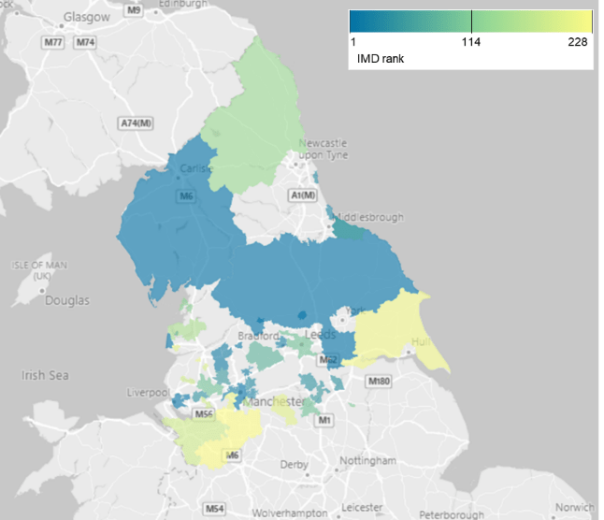
Figure 3: Map of IMD rankings for the affected boroughs

6.2.12 Crime Rates
We are analysing crime rates, given certain individuals who share protected characteristics are more likely to be impacted by crime than others – and therefore will have different vulnerabilities and impacts associated with Northern’s reform project. For instance, certain groups may be more at risk of being victims of hate crimes, therefore station facilities and colleague presence will be more important factors for these groups.
Table 14 presents the number of crimes reported to police in the affected boroughs and compares this to national figures. Despite accounting for under 20% of England’s total population, the affected boroughs account for 24% of England’s total reported crimes. Note that not all crimes are not reported to the police and thus police reported crimes do not give a full depiction of general trends in crime.
Table 14: Number and type of crime. ONS 2022.
Type of crime | Crime in Affected Boroughs | Crime in England
Total crime | 1,198,578 | 4,912,794
Violence against the person | 479,322 | 1,870,328
Sexual offences | 38,883 | 172,812
Robbery | 11,737 | 67,731
Theft offences | 314,441 | 1,523,640
Criminal damage and arson | 123,297 | 466,006
Drug offences | 35,310 | 150,216
Possession of weapons offences | 12,379 | 50,235
Public order offences | 153,867 | 507,697
Miscellaneous crimes | 29,372 | 104,129

In line with the rest of England, crimes of ‘violence against the person’ (homicide, death or serious injury caused by illegal driving, violence with injury, violence without injury, and stalking and harassment) account for the greatest proportion of police report crimes in the affected boroughs (40%). This is followed by threat offences (residential burglary, non-residential burglary, vehicle offences, theft from person, bicycle theft, shoplifting, and all other theft offences) and public order offences (26% and 13% respectively). No correlation was found between crime rates and deprivation in this assessment; however, other studies have shown that recorded crime is more prevalent in the neighbourhoods with the highest levels of income deprivation. Note that crime statistics need to be viewed in context; for instance, boroughs with bigger population sizes may generate more reported crime than those with smaller populations.

Figure 4: Map of total numbers of crime in each affected borough
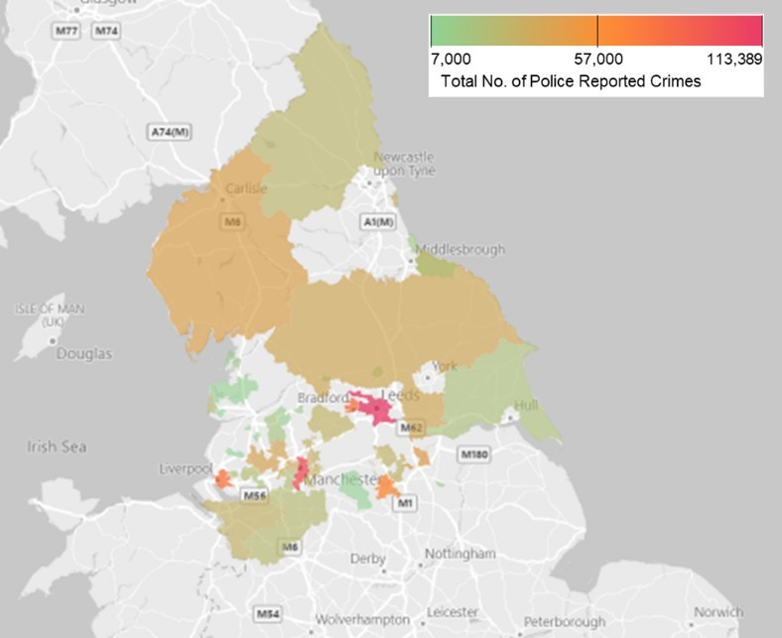

6.2.13 Station Crime
Violent crime (32%) was the most common crime committed at the affected stations. This was followed by public order offences (21%), which together account for over half of all station crimes. This was followed by drug offences (8%) and other theft offences (8%).

Figure 5: Station Crime by type of crime. British Transport Police (2023).
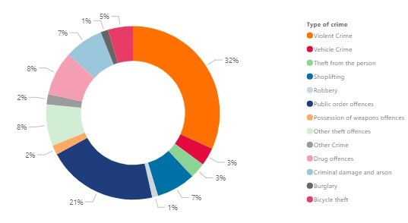
Leeds station had the greatest number of recorded crimes. This was followed by Manchester Victoria and Bolton. Data was not available for all the stations.

6.2.14 Hate Crime
Hate crimes are taken to mean any crime where the perpetrator's hostility or prejudice against an identifiable group of people is a factor in determining who is victimised. It is spilt into five overarching categories: race, religion, sexual orientation, disability, and transgender. Note that the figures measure the motivating factors, and thus this figure differs from the total number of offences. Data is spilt by police force area; boroughs were matched to their respective police force areas which can span across several boroughs. For the breakdown of police force areas, see Annex B.
Table 15: Hate crime, England and Wales, 2021 to 2022. Home Office 2022.
Type of hate crime | Hate crimes in Affected Boroughs | Crime in England
Total number of offences | 51,318 | 155,841
Total number of motivating factors | 54,194 | 163,322
Race | 34,977 | 109,843
Total religion | 2,758 | 8,730
Sexual orientation | 9,300 | 26,152
Disability | 5,564 | 14,242
Transgender | 1,595 | 4,355

Race was the prime motivating factor for hate crime, accounting for 67% of all hate crime in England. This was followed by sexual orientation (16%), disability (9%), religion (5%) and transgender (3%). The affected boroughs account for approximately a third of all hate crime in England.

6.2.15 Rail Commuters
Figure 6 illustrates the population within 3km of stations which Northern serve. It uses Census 2021 travel to work data to estimate the commuter market around these stations. Children are excluded here as this data only represents travel to work data. Note that this figure is indicative as it looks at rail as a whole and not markets exclusive to Northern and does not consider leisure travel. Whilst 2021 data underestimates rail commuting data due to the Covid-19 pandemic, ways of working and commuting patterns (i.e., employees working from home) have considerably changed since 2021 and are not expected to return to these levels in the near future.
Figure 6: Rail commuters within 3km of the Northern served rail network by age
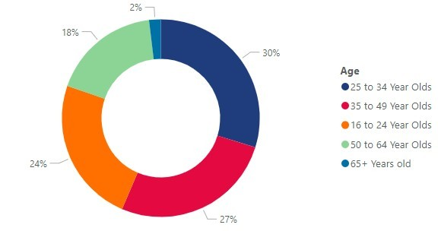
Figure 7 breaks down the commuter patterns by region and age. The greatest amount of commuting occurs in the East region, where it is dominated by 25 to 49-year-olds. The North East region has the lowest number of commuter journeys. In all the regions, 25 to 34-year-olds account for the largest proportion of commuters, whilst the over-65 population is dramatically lower.
Figure 7: Rail commuters within 3km of the Northern served rail network by region
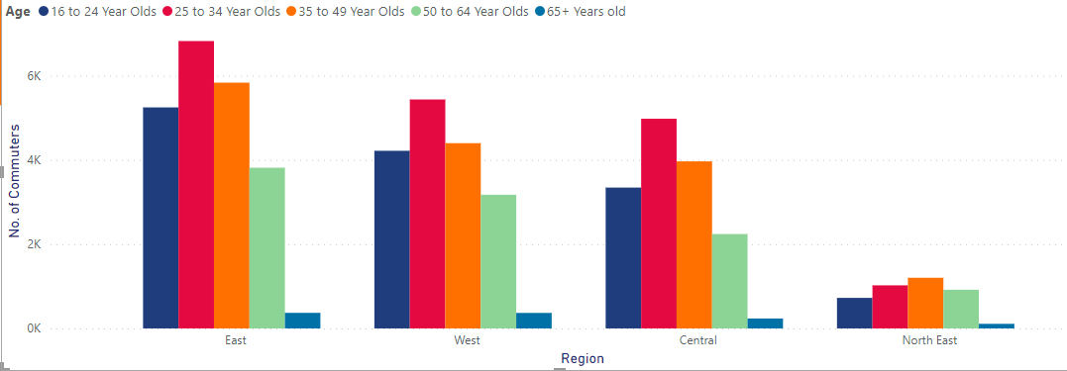
Of these journeys, the 25 to 34 years population accounted for the greatest proportion of these journeys. Less frequented commuter journeys, such as Oxenholme to Windermere, may be due to the lack of jobs in these areas and smaller populations.
Commuting accounts for a large proportion of rail usage. However, it has been found that there is often a “mismatch between ‘where people are’ and ‘where jobs are’”, that despite the availability of local transport, education and employment opportunities may be limited. In addition to the uneven geographic distribution of employment opportunities, transport networks were found to be slow, congested, and unintegrated.

6.2.16 Station Footfall
Station footfall data was taken from Office of Rail and Road (ORR). Total footfall is the total number of entries and exits in a station, regardless of ticket type (e.g., off-peak ticket, season ticket, etc.). Covid-19 had a severe impact on rail travel due to lockdown restrictions, causing a dramatic decline in rail usage. As such, figures from April 2020 to March 2021 have been excluded from this analysis.
Between April 2019 and March 2020, total footfall was over 142 million. Leeds was the busiest station with over 31 million entries and exits. This figure is nearly double that of the next busiest station, Liverpool Lime Street, at 16 million. Manchester Victoria and Manchester Oxford Road were the next busiest stations. The boroughs in which these stations are situated have some of the largest populations of the affected boroughs, as well as the largest adult populations. This may indicate that the large footfall is due to people commuting to big cities for work. The stations with the lowest footfalls, all located in the West and Central regions, were Hag Fold (48,138), Glazebrook (48,808) and West Allerton (55,072).
Between April 2021 and March 2022 rail travel started to increase again, however, due to societal changes from the pandemic, such as work from home, rail usage is not expected to return to its pre-pandemic levels. Total footfall in this period was 93.2 million, nearly 50 million lower than pre-pandemic levels. Leeds, Liverpool Lime Street and Manchester Victoria and Manchester Oxford Road remained the busiest stations; however, footfall was dramatically lower (e.g., the total footfall at Leeds station was 19.2 million). Glazebrook remained as one of stations with the lowest footfall (23,552), however, footfall at Chassen Road (26,166) and Farnworth (43,744) decreased since the pandemic, replacing Hag Fold and West Allerton as the least busy stations. Hag Fold and West Allerton stations, however, remain in the top 5 least busiest stations. This may be due to Wigan (Hag Fold Station) having one of the smaller populations (~329,000 people) of the affected boroughs and is not an economic hub. However, West Allerton station, located in Liverpool, may have a lower footfall due to Liverpool Lime Street station being bigger and more connected.
Typically, stations that are not located in economic hubs (i.e., major cities) where commuting is the main reason for rail usage, may explain the small footfalls at such stations. Similarly, stations that are situated in boroughs with smaller populations (except for Liverpool), and which are comprised of greater proportions of children and elderly who do not commute, will also have smaller footfall.

6.3 Our Data
This section highlights the data that we collect on various factors that are pertinent to this equality analysis, including: station accessibility, total footfall, passenger assist bookings, sales data, ticket vending machines, and customer complaints at staffed stations.

6.3.1 Station Accessibility
Stations are categorised into five categories according to their level of accessibility:
- A: Step free access to all platforms via level crossings, lifts, ramps.
- B1: Step free access to all platforms – may include long or steep ramps. Access between platforms may be via the street.
- B2: Some step free access to all platforms.
- B3: Some step free access, may be in one direction only.
- C: The station has no step free access to any platform.
See Appendix B for the breakdown of Northern’s stations by accessibility category.
49 % of the affected stations are Category B and 11% are Category C. The 40% of stations that have an A accessibility category would not experience changes to their accessibility (in terms of stepping onto the platform or train) as a result of the proposed policy.

6.3.2 Northern Passenger Assist Bookings
Through the industry-wide booking assistance platform, called Passenger Assist, Northern customers can book assistance at stations and for boarding and alighting our trains. According to our data, between P12 2022 and P13 2023 Northern passengers made 107,487 bookings for assistance on the system. Of these 19,935 were cancelled, resulting in 87,552 completed bookings. Booking cancellations can occur for a multitude of reasons, such as travel amendments or train strikes.
Of the bookings placed during this period:
- Nearly one-third (31%) of passenger assistance bookings were for the 18 TO locations proposed to remain.
- Monday to Thursday are the most popular days for passenger assistance. However, there is a spread of volume across the week. Sundays are the lowest with 9% of all bookings.
- 94% of bookings are between the hours of 8:00 and 21:00.
- 75% of bookings requested assistance both at departure and arrival station.
- 95% of bookings are for alighting a train, with 82% requests for boarding a train.
Random sampling was undertaken on the 107,487 Northern Passenger Assist (PA) requests data to identify other key themes. The data was filtered to include the affected stations owned and managed by Northern. A random number was allocated to each PA request and the top and bottom 10 requests (20 in total) were selected to be assessed. Note that some requests asked for multiple types of assistance. Our sampling exercise found that most PA requests were for help getting on and off the train, rather than assistance at the station itself. Nearly half of the PA requests were for help with luggage. Ramps, to get on and off the train with wheelchairs and station buggies were the next most common requests. Of the selected requests, help due to being deaf was requested once. Due to the random sampling, no geographical trends were found.
A 2023 external customer research survey by ORR on Experiences of Passenger Assist highlighted the below findings:

- Most passengers booking assistance are aged over 65 (66%), with the proportion under 50 years old booking assistance (13%).

- The most common type of disability among users is physical (67%), followed by hearing (18%), vision (15%) and learning (8%).

- The most commonly booked services were assistance boarding the train (60%), help with luggage (56%) and alighting the train (44%).

- After making their booking, seven in ten (71%) felt confident that all their requirements would be met.

A 2019 DfT study found that over a third of disabled passengers never book assistance services in advance when travelling by rail. In these instances, there is also a ‘Turn up and Go’ service whereby passengers can arrive at the station and request assistance that has not been booked in advance. Station operators are required to provide assistance to passengers, even if this has not been arranged in advance, where this is reasonably practicable. To help Northern understand the types, timing and frequency of passenger requests made without a booking, an employee survey (covering 59 employees from 15 stations and 14 depots) was conducted. This revealed:
- Assistance with luggage, use of ramps and sighted guidance were the most required types of customer assistance at stations. Other types of assistance include help pushing a wheelchair, help transferring trains, use of a station wheelchair and use of a station buggy.
- 69% of colleagues complete assistance every day.
- Peak times for assistance are off-peak midweek (between 9:00 and 16:00), i.e., outside the traditional peak commuter travel period.
Of all stations, Leeds received the highest number of passenger assist bookings (9,786), followed by Blackpool North (6,936), Manchester Victoria (3,678), Liverpool Lime Street (2,748) and Manchester Oxford Road (2,589) stations. These stations will all retain a full staffing presence. Most stations received less than 1,000 passenger assist bookings between P12 2022 and P12 2023. Higher number of bookings are correlated with high station footfall and large local populations. As seen in Figure 8, there does not appear to be a positive correlation between station passenger assist bookings and the proportion of disabled populations in their local boroughs. Note that not all passenger assists, such as ‘Turn up and Go’ services, are recorded.
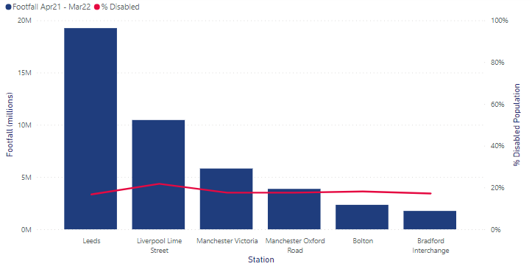
Figure 8: Six busiest stations (by footfall) and proportion of disabled people in their respective boroughs

6.3.4 Ticket Vending Machines (TVM)
Northern has over 300 TVMs across the 149 affected stations, with all stations having at least one TVM. The number of TVMs per station is positively correlated with footfall, with the busier stations, such as Leeds, having the greatest number of TVMs (11). Northern reviewed the current and forecasted demand and has concluded that the TVM's have sufficient capacity to accommodate additional transactions arising from TO closures.
All TVMs can accept card payment via contactless and Chip & Pin. Nine of our TVM's accept cash. All TVMs can retail national fares, with a few exceptions, and have live train running and rail replacement information. All of our TVMs are enabled for ticket collection when the ticket is booked on-line. All card-only TVMs that are located at stations without a ticket office will have the Promise to Pay functionality enabled to allow customers to pay by cash at the first opportunity. At present, 33 TVMs have Video Assistance enabled (2 of which are at impacted stations), which allows a colleague in our contact centre to talk to customers and help them buy the ticket to the point of payment. Northern is running a pilot for Video Assistance across a wider network and seeking extending this functionality to all TVMs, subject to funding.

In 2023, Northern conducted an accessibility study of the TVMs. To date, nearly all TVMs have been assessed and 20 are remaining to be surveyed. The assessment classified TVMs with a high, medium, or low accessibility risk. Of those assessed, 26 TVMs were found to have accessibility issues, 17 of which were classified as high risk. 2 TVMs were classified as medium risk, and 7 with low risk. 11 of these TVMs are in stations impacted by this project (Alderley Edge, Dinting, Driffield, Gorton, Greenfield, Guiseley, Hadfield, Handforth, Morecambe, Sandbach and Workington). All TVMs have adjustable screen height functionality which increases physical accessibility.

Customer complaints by staffed station
The majority of complaints targeted station colleagues rather than train colleagues; 72% of complaints were about the attitudes and helpfulness of the colleagues at the station. Only 11% of complaints regarded train colleagues.

Figure 9: Customer complaints by staffed station by topic
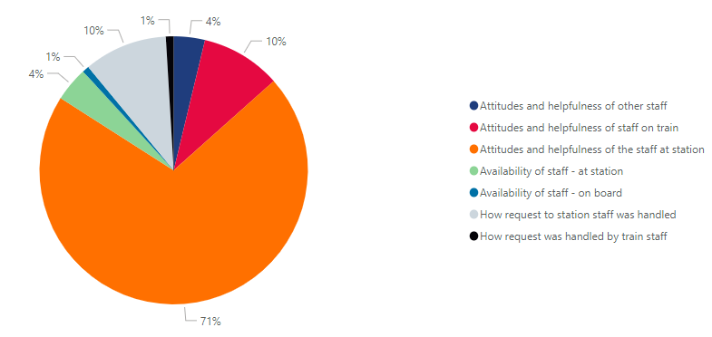
As would be expected, stations with the highest footfall receive the highest number of customer complaints. Leeds stations received the most complaints (103), a far greater amount than the next most complained about station, Manchester Victoria (47). After this, Liverpool Lime Street (41) and Manchester Oxford Road (35) stations received the greatest number of complaints.

6.4 Engagement and Consultation
In preparation of this equality analysis, Northern will be undertaking the following consultations with customers on the proposed changes.
Engagement Method | Stakeholder
1. Engagement panels | Northern’s Accessibility User Group Panel (NAUG)
2. Interviews at select stations (see Section 8) | Customers
3. Formal consultation | General public

Further details on the engagement method and the data collected are outlined below.
- Engagement panels with equality organisations: Northern conducted a focus-group session with some of its Northern Accessibility User Group members before the formal consultation period. The key objective of this discussion was to obtain insights and feedback on the likely impacts of the reforms plan and policy early-on in the process, and for Northern to incorporate the feedback and insights received into consideration before finalisation. The panel session was customer-focused in order to understand the perception of the impact of the reform on the various groups of customers, especially those within any protected characteristic groups.
- Interviews with customers at select stations: Northern developed case studies (as highlighted in Section 8) for four randomly selected stations to understand the impact of the reform on the station’s customers. Northern obtained insights for these case studies through engaging with customers at the selected stations. The customer engagement during the station visits covered station-specific incidents, such as number of Passenger Assist bookings, impact on customer experience due to proposed reforms around relocating some colleagues, and other interactions between the colleagues and customers.
- Formal consultation: Through Transport Focus, Northern launched formal consultations with an invitation for responses from the public on the reforms.

7. Potential Impacts

An equality analysis assesses the outcome of a project from the viewpoint of a number of groups who share a protected characteristic, including:
- Age
- Sex
- Disability
- Race
- Religion or belief
- Sexual orientation
- Pregnancy and maternity
- Marriage and civil partnership
- Gender reassignment
In examining the impacts, we have also considered the intersectional issues that pertain to individuals because of their multiple social identities, such as gender, class, sexuality, and race (e.g., an ethnic minority cisgender woman). We recognise that different individuals will have intersecting or overlapping identities, which may pre-dispose them to varying experiences of discrimination and privilege.
To avoid repetition, potential impacts that pertain to all protected characteristics are outlined in the table below. Subsequently, we have broken down potential impacts by each protected characteristic to Northern’s customers. We then summarised the impacts against the three strands of the Equality Act in Section 9.
A detailed breakdown of protected characteristics impacts by station can be found in Appendix B.

7.1 Potential positive impacts on all protected characteristics
Improved customer experience
The Journey Maker is a customer-facing role that will offer guidance and general support for customers with queries, ticket purchasing support, direction during disruption, mobility assistance and wayfinding.

The transition from ticket office colleagues to Journey Maker may increase the visible presence of colleagues in and around the station environment, increasing the perception of safety and security at the station and make passengers feel more comfortable when travelling. The Journey Maker will also help to address customers’ requests for more information when travelling, provide directions to facilities (i.e., a certain platform), and provide general assistance. Technology deployed by Journey Makers will offer increased translation ability, at the station and conductors on train will have Passenger Assistence technology available.

Increased access to facilities
As a result of this change, some of our current facilities will be open for longer than they are currently and be made more accessible. All facility opening hours will be maintained or increased. This is documented in Appendix A, Appendix C and Appendix D.

7.2 Potential negative impacts on all protected characteristics
Safety and community for customers
The reduction in the presence of staff may create a perception amongst customers that stations are less safe than they are today.

Vacant buildings maybe subject to vandalism, squatters, fires, antisocial behaviour, and general damage if not secured appropriately. This may deter passengers from travelling due to the appearance of an unsafe environment. Some people express concerns about using public transport because of a particular characteristic they have, such as their gender or race, or because they need to travel at certain times of the day or night. Feelings of safety can be affected by the condition of stations where these are dirty, littered or vandalised, as can poor behaviour of passengers and colleagues. There may be blind spots in the station, i.e., no CCTV coverage, which are prone to instances of anti-social behaviour and crime.
Lack of payment choice
Customers at 131 stations will not be able to use cash to purchase ticket products in or at the station, impacting those who rely on cash as a payment method. Despite alternative cash purchase channels being in place, this may inconvenience some customers as they will need to print a Promise to Pay ticket from a TVM before boarding a train. This will particularly impact the elderly, and/or communities that are more deprived, as they are more likely to prefer cash as their valued form of money.&
Reduced accessibility support from station staff
The proposed stations reform will bring a change in the routine for many customers, potentially creating increased levels of stress and anxiety. The total number of station staffing hours is reducing across the majority of stations impacted in this proposal, meaning that some accessibility requests may not be able to be supported during the same hours that they are currently, in particular ‘turn up and go’ requests. As such, some customers with disabilities may not receive assistance during hours where the staff presence has been removed. This may discourage some passengers from using the railway.
Reduction in access to different product types at station
Not all ticket products currently available to purchase at ticket offices will be available on the station TVM. Whilst most products can be purchased digitally, customers seeking to purchase products in person will need to travel to their nearest ticket office, which may inconvenience them when compared to the service they receive currently. This may deter customers from using Northern services due to the difficulty, extra cost and extra journey time required to obtain their desired tickets.

7.3 Equality Impact Summary
This section details the potential positive and negative impacts for each of the protected characteristics. For each protected characteristic, we have provided a summary upfront on an overview of the demographics data. In the absence of internal data, such as colleagues sexual orientation, general UK data has been used.
Summary of key changes proposed under the Ticket Office Reform | Stations Retailing Reform  - Planned closure of 131 Ticket Offices in a phased manner over a period of 18 months.  - Making changes to ticket office hours at 18 stations and that will retain existing retailing capabilities.  Stations Multiskilling Reform  - Redeployment of some colleagues members to a multiskilled, flexible, stations-based role called the ‘Journey Maker’.
Acronyms | JM = Journey Maker  PA = Passenger Assist  TVM = Ticket Vending Machine  TO = Ticket Office
Specific groups to consider | Age, Disabled, Gender reassignment, Marriage and Civil Partnership, Race, Pregnancy and Maternity, Religion and Belief, Sex and Sexual Orientation

7.4 Age
OVERVIEW & STATIONS MOST IMPACTED: In the affected boroughs, the elderly (65 years and older) account for 19% of the total population and adults 64%. As the UK has an ageing population, it is projected that the number of older people (those aged 85 years and over) will almost double to 3.1 million by 2045, representing 4.3% of the total UK population. This growing elderly population will have their own set of physical, mental, and social requirements, the accommodation of which would require certain structural economic and societal shifts. Fylde (27.9%), Wyre (27.8%) and East Riding of Yorkshire (26.5%) have the highest proportion of elderly people today and subsequently the lowest proportion of children of all the affected boroughs. 7 stations are situated in these boroughs: Beverley, Bridlington, Driffield, Goole, Kirkham & Wesham, Poulton-Le-Fylde, and St Annes-On-The-Sea. The likelihood of being a victim of crime decreased with age, with 18% of 16- to 24-year-olds having been a victim of crime and 5% of those aged 75 years or older having been a victim of crime. This is due to higher instances of sexually orientated crimes against younger people compared to older people who were more likely to be victims of crimes related to theft.

AGE
Positive impacts | Negative impacts
Improved customer experience  - Northern intends to implement the national Passenger Assistence app for conductors which will enable them to better respond to the assistance requests from elderly customers. These requests will also appear on the Journey Maker’s tablet, enabling them to respond more quickly and efficiently to any requests and emergencies.  - The introduction of the Journey Maker role is likely to decrease travel complexity for elderly people as there will be easy access to help and assistance on the platform (as advertised times).  - Millennials and Gen Z travellers are frequent mobile users and prefer the digital booking experience. The increased digitalisation of different ticket types may increase customer satisfaction. | Passenger Assistence capacity  - 69% of PA bookings are at stations where there will be a revolving Journey Maker presence. Journey Makers will be at a station for an average of 29 hours per week compared to 73 hours currently staffed by Ticket Office colleagues.  Digital exclusion  - Northern expects that most Ticket Office transactions will migrate to digital retailing channels like National Rail or Northern App. As a higher proportion of older people (as compared to younger cohorts) remain digitally excluded, it may be difficult for them to adjust to the new changes. Health problems like arthritis, poor eyesight and memory loss can make it more difficult for the elderly to navigate a smartphone.  Inconvenience  - Age UK found that those 65 years and older deem public transport inconvenient and does not suit their needs. The potential reduction in facility availability, as well as station colleagues, has the potential to further disincentivise elderly customers from Northern services.  Payment method exclusion  - For customers whose preference is to pay with cash, the elimination of cash as a payment method at stations via the ticket offices may exclude the elderly from accessing public transport.

7.5 Disability
OVERVIEW & STATIONS MOST IMPACTED: Blackpool (25.1%), Sunderland (23.5%) and Hartlepool (17.9%) have the largest disabled populations in the affected boroughs. Three stations are located in these boroughs – Blackpool North, Sunderland and Hartlepool – all of which have an A Accessibility Category. 10% of hate crimes in the affected boroughs are disability related, however these boroughs have lower levels of overall hate crime. No correlation between the proportion of disabled population and disability related hate crimes was identified.
Across the UK, people with a disability were slightly more likely to have experienced crime (14%) than people who did not have a disability (13%). This is due to the perceived vulnerability of this cohort of people.
Trafford (16%), Leeds (16.7%) and Cheshire East (17%) have the smallest disabled populations. 18 stations are situated in these boroughs: Alderley Edge, Congleton, Cross Gates Yorks, Disley, Garforth, Guiseley, Handforth, Holmes Chapel, Horsforth, Knutsford, Leeds, New Pudsey, Poynton, Sandbach, Wilmslow (and Leeds Travel Centre).
Nearly half of the affected stations have a B accessibility category, meaning that accessibility is limited to varying degrees.

DISABILITY
Positive impacts | Negative impacts
Improved customer experience  - Disabled people continue to report receiving inadequate or inappropriate service across the UK transport network. DfT found evidence that disability training to existing colleagues could improve the service experience for disabled customers. Northern plan to enhance its disability training included in the Journey Maker programme and for other station staff. As such, the new training programme will upskill Journey Maker colleagues and improve the overall customer experience for those with a disability.  - A North Somerset Council study stated that approximately 3.5% of the UK population are visually impaired. With the introduction of the tablets used by the Journey Maker colleagues, this enables an audio function which may assist customers with visual impairments.  - Similarly, according to the UK Government, 11 million people in the UK population have a hearing impairment. The tablets used by Journey Maker colleagues will include a subtitle function which may make instructions and directions more accessible for people with this disability.  - At stations that have high footfall, Northern plans to introduce additional wayfinding.  Journey Maker visibility  - Presence of staff on the station (rather than in the ticket office) may increase the perception of customer support and safety on the station platform. | Passenger Assistence capacity  - 69% of PA bookings are at stations where there will be a revolving Journey Maker presence. Journey Makers will be at a station for an average of 29 hours per week compared to 73 hours currently staffed by Ticket Office colleagues.  Safety concerns  - Disabled people are at greater risk of incidents of abuse and unwanted sexual behaviours; in recent years, there has been a 43% increase in the number of disability-related hate crimes. The lack of colleagues presence may increase personal security and safety concerns when travelling.  Poor facilities for the visually impaired  - 49% of train stations in Great Britain have either no or only partial tactile surfaces on operational platforms. This means visually impaired customers who cannot navigate stations independently may currently rely on station colleagues to support their journey around the station. A reduction in colleagues members may adversely impact them.  - 40% of visually impaired customers were not able to make all the journeys they wanted or needed to make. The stations staffing hours are decreasing resulting in less access to station staff for the visually impaired, which may increase the number of visually impaired customers who are not able to make the journeys they want.  Turn up and Go assistence  - Over a third of disabled rail passengers in Great Britain do not book book assistance in advance. Instead, passengers tend to depend on colleagues at stations for assistance. A reduction in the number of colleagues to meet this on-the-spot support request has the potential to negatively impact the travel experience of those disabled people who do not book passenger assistance in advance.  Poor accessibility  - Wheelchair users may not find some of the TVMs accessible, given the screens are above seated level. In the absence of Ticket Offices, this may impact on their ability to purchase tickets independently.  - Stations that have barrow crossings (i.e., a designated point for individuals to cross the tracks between the platforms) as part of their infrastructure reduce the accessibility of the station for disabled people. At stations that are not staffed, the platform may not be accessible during this time. This may negatively impact the travel experience for disabled people.

7.6 Gender reassignment
OVERVIEW & STATIONS MOST IMPACTED: The levels of gender reassignment are low across the affected boroughs, with most residents identifying with the same sex as registered at birth. Manchester has the most diverse population in this regard, however, those that identify as transgender or non-binary is less than 1% of the total population here (7.3% of the population did not respond). There are 8 stations in this borough – Burnage, Deansgate, East Didsbury, Gorton, Levenshulme, Mauldeth Road, Manchester Oxford Road, and Manchester Victoria. Boroughs such as South Ribble, Fylde and Northumberland have the least variation, with over 95% of the population identifying as the same sex as registered at birth (and nearly 5% of the population did not respond). There are 6 stations located in these 3 boroughs – Kirkham & Wesham, Leyland, St Annes-On-The-Sea, Hexham, Morpeth and Alnmouth. Note that these figures do not equate to 100% as a percentage of people did not answer the census question.
Individuals whose gender identity is different from their sex registered at birth (trans or transgender), were significantly more likely to have been a victim of crime in 2020. More than 1 in 4 people who were trans (28%) had experienced crime compared with 14% of those whose gender identity is the same as the sex they were registered at birth (cisgender).
Transgender hate crimes account for 3% of all hate crimes in the affected boroughs. Whilst this is the smallest proportion of reported hate crime here, transgender related hate crimes have increased in recent years. Greater Manchester police force area – Bolton, Manchester, Oldham, Rochdale, Salford, Stockport, Tameside, Trafford, and Wigan – where 41 stations are located, experiences the highest level of overall and transgender related hate crime.

Gender reassignment
Positive impacts | Negative impacts
Journey Maker visibility  - Presence of staff on the station (rather than in the ticket office) may increase the perception of security on the station platform.  - The addition of body cameras and local microphones on Journey Maker colleagues will allow them to monitor situations where customers may require assistance. | Hate crimes  - There has been a 56% increase in the number of transgender hate crimes in recent years. The presence of colleagues at stations has been identified as an important variable regarding the perception of safety. The reduction in colleague numbers and thus colleague presence may decrease trans customers’ perception of personal security and safety.

7.7 Marriage and Civil Partnership
OVERVIEW & STATIONS MOST IMPACTED: Tameside (7.1%), Knowsley (7%) and Sunderland (6.9%) have the greatest number of same-sex marriages. 6 stations are situated in Tameside (Ashton-Under-Lyne, Broadbottom, Hattersley, Newton For Hyde, Guide Bridge and Mossley (Manchester)), 5 in Knowsley (Halewood, Huyton, Prescot, Roby and Whiston) and 1 in Sunderland (Sunderland station). Same-sex marriages accounted for at least 1.5% of all marriages in the affected boroughs. Data on this topic was not available for all the boroughs.
Positive impacts | Negative impacts
Increased safety features  20% of LGBTQ+ commnunity have experienced a hate crime or incident because of their sexual orientation and/or gender identity in 2017.  - Presence of staff on the station (rather than in the ticket office) may increase the perception of security on the station platform.  - The addition of body worn cameras and local microphones on Journey Maker colleagues will allow them to monitor situations where customers may require assistance. | Decreased perceptions of safety  - 66% of people in same-sex marriages felt unable to operate freely in society due to fear of experiencing discrimination or harassment. The reduction in colleague numbers and thus colleague presence may decrease same-sex customers’ perception of personal security and safety.

7.8 Race
OVERVIEW & STATIONS MOST IMPACTED: Blackburn with Darwen (35.7%) and Bradford (32.1%) have the largest Asian populations, as well as the smallest White populations (60.4% and 61.1% respectively) of all the affected boroughs. 1 station is situated in Blackburn (Blackburn station), whereas 7 are situated in Bradford (Bingley, Bradford Forster Square, Bradford Interchange, Ilkley, Keighley, Menston, and Shipley).
Manchester (11.9%) has the greatest Black population at over 5% (Salford having the next biggest Black population at 6.1%), as well as the greatest Mixed (5.3%) and Other (5.1%) ethnicity populations. It is the most diverse borough, with a White population of 56.8%, the lowest of all the affected boroughs. 8 stations are situated in Manchester – Burnage, Deansgate, East Didsbury, Gorton, Levenshulme, Manchester Oxford Road, Manchester Victoria and Mauldeth Road. In all the other boroughs, the proportion of those of Mixed and Other ethnicities is equal to or less than 3.8% and 3.3% respectively.
Redcar and Cleveland have the greatest White population (97.7%). Only one station is located here, Redcar Central station. In Bassetlaw, East Riding of Yorkshire, High Peak, Northumberland and Wyre, the White population accounts for at least 97% of the total population, illustrating the lack of ethnic diversity in these areas. There are 16 stations located in these boroughs: Alnmouth, Beverley, Bridlington, Buxton, Dinting, Driffield, Glossop, Goole, Hadfield, Hexham, Morpeth, New Mills Central, New Mills Newtown, Poulton-Le-Fylde, Whaley Bridge and Worksop.
The most diverse boroughs include but are not limited to Leeds, Liverpool, Oldham, Stockport, and Tameside. 34 stations are situated in these boroughs. 6 stations (and the Travel Centre) are in Leeds (Cross Gate Yorks, Garforth, Guiseley, Horsforth, New Pudsey and Leeds), 6 are in Liverpool (Broad Green, Edge Hill Liverpool, Liverpool Lime Street, Mossley Hill, Wavertree Technology Park, West Allerton), 1 station is in Oldham (Greenfield), 14 are in Stockport (Bramhall, Bredbury, Brinnington, Cheadle Hulme, Davenport, Gatley, Hazel Grove, Heaton Chapel, Heald Green, Marple, Reddish North, Romiley, Rose Hill (Marple), and Woodsmore) and 6 are in Tameside (Ashton-Under-Lyne, Broadbottom, Guide Bridge, Hattersley, Mossley (Manchester) and Newton For Hyde).
Race was the prime motivating factor for hate crime, accounting for 65% of all hate crime in the affected boroughs. Greater Manchester police force area – Bolton, Manchester, Oldham, Rochdale, Salford, Stockport, Tameside, Trafford, and Wigan – had the greatest number of overall crimes, as well as the highest proportion of race related hate crime. These boroughs have some of the most ethnically diverse populations of all the affected boroughs. 41 stations are situated in these boroughs, over a quarter of all the affected stations, and they may be susceptible to high rates of racial hate crime, especially with a perceived lower presence of colleagues.

Positive impacts | Negative impacts
Increased perception of safety  Ethnic minorities are more dependent on public transport; In 2020, 16% of the distance travelled by Black people were on overground rail, the highest percentage out of all ethnic groups. The lowest percentage was for White people (9%).  - Presence of staff on the station (rather than in the ticket office) may increase the perception of security on the station platform.  - The addition of body cameras and local microphones on Journey Maker colleagues will allow them to monitor situations where customers may require assistance.  Improved communication with customers  - The Journey Maker training upskills employees and teaches them ways to work with people who do not have English as their first language.  - Devices and tablets used in the Journey Maker role have easy access to Google translate, making it easier for customers who do not have English as their first language to interact with the colleagues and ask for assistance. | Hate crimes  - Unstaffed stations without additional infrastructure mitigations could represent an increased risk to passenger safety.  - The reduction in colleague numbers and thus colleague presence may decrease customers perception of personal security and safety.

7.9 Pregnancy & Maternity
OVERVIEW & STATIONS MOST IMPACTED: On average, the Total Fertility Rate (TFR) of all the affected boroughs (1.62) is higher than the national rate (1.55). This is applicable to 69% of the affected boroughs, indicating that women on average have more live children in the North of England. Oldham has the highest TFR at 1.93, and Leeds had the greatest number of live births (8784) of any borough. 6 stations (and the Travel Centre) are in Leeds (Cross Gate Yorks, Garforth, Guiseley, Horsforth, New Pudsey and Leeds), and 1 station is in Oldham (Greenfield).
Positive impacts | Negative impacts
Increased assistance  - Pregnant customers or those with maternity responsibilities might benefit from the presence of a visible colleagues at stations. For example, they could use the Journey Maker for help and assistance when required (e.g., boarding and alighting the train, carrying buggies, help on the stairs and around the station).  - Visible presence of staff on the station (rather than in the ticket office) may increase the perception of security on the station platform. | - Pregnant women may have restricted movement and might need support from colleagues in case of emergencies. Commuting to work can be a major source of stress and anxiety for pregnant women . Pregnant women often make adjustments to their commute, such as traveling outside peak times. If colleagues are not available during these hours, pregnant women may feel excluded from Northern’s services.  - The reduction in colleague numbers and thus colleague presence may decrease customers perception of personal security and safety.  - 60% of impacted stations are Category B and C stations which have step free access and may increase pregnant womens’ difficulties in moving around the station, as well as mothers that may be travelling with childrens’ buggies and strollers. The reduction in staffing hours at stations may negatively impact customers with this protected characteristic, in particular for any ‘turn up and go’ requests.

7.10 Religion or Belief
OVERVIEW & STATIONS MOST IMPACTED: On average, there are a greater proportion of Christians in the affected boroughs (49.1%) than the national average (46.3%). Knowsley (66.6%) has the great proportion of Christians, with another 32% declaring that didn’t have a religion or was not stated. 5 stations are in this borough: Halewood, Huyton, Prescot, Roby and Whiston. All other religions only accounted for 0.18% here. Wigan (62.8%), St. Helens (62.3%), and South Ribble (61.8%) also had large Christian populations. Stations (14) in these boroughs include: Atherton, Hag Fold, Hindley, Wigan Wallgate, Earlsetown, Eccleston Park, Garswood, Lea Green, Newton-Le-Willows, Rainhill, St Helens Central, Parbold, and Leyland.
In all boroughs, Buddhists account for less than 1% of the total populations. Manchester has the biggest Buddhist population at 0.58%. 8 stations are situated in Manchester – Burnage, Deansgate, East Didsbury, Gorton, Levenshulme, Manchester Oxford Road, Manchester Victoria and Mauldeth Road. Bolton and Tameside have the greatest Hindu populations (2% and 1.9% respectively), with nearly all other boroughs having very small Hindu communities (less than 1%) except for Leeds (1.14%), Manchester (1.1%) and Tameside (1.3%). 5 stations are in Bolton – Bolton, Bromley Cross, Daisy Hill, Farnworth, and Lostock Parkway – and 6 stations are in Tameside – Ashton-Under-Lyne, Broadbottom, Hattersley, Newton For Hyde, Guide Bridge and Mossley (Manchester). Salford has the biggest Jewish community (3.8%), with Jewish populations in all other boroughs accounting for less than 1% of the population, except for Trafford (1.02%). 5 stations are in Salford – Eccles, Salford Central, Salford Crescent, Swinton (Greater Manchester) and Walkden. All four of these boroughs are grouped in the Greater Manchester police force area, which has the highest overall and religion related hate crime of the affected boroughs. Religion hate crimes account for 6% of all hate crimes in the affected boroughs.
Blackburn with Darwen (35%) and Bradford (30.5%) have the largest Muslim populations. Blackburn station is the only station located in Blackburn with Darwen, and 7 stations are located in Bradford (Bingley, Bradford Forster Square, Bradford Interchange, Ilkley, Keighley, Menston, and Shipley). With the exceptions of Bolton (19.9%), Burnley (14%), Hyndburn (14.6%), Manchester (22.3%), Oldham (24.4%), Rochdale (18.8%) and Sheffield (10.3%), all other boroughs had small Muslim populations (accounting for less than 10% of the total population). Leeds has the biggest Sikh population (1.2%), with Sikhs accounting for less than 1% in all other boroughs.
The Buddhist, Hindu, Jewish, and Sikh communities are smaller in the affected boroughs than the national averages. Here, the Christian and Muslim communities are greater than the national averages. Staff data on religion was not available

Positive impacts | Negative impacts
Increased perception of safety  - Visible presence of staff on the station (rather than in the ticket office) may increase the perception of security on the station platform.  - The addition of body worn cameras and local microphones on Journey Maker colleagues may act as a deterent to any abusive, violent or hateful behaviour. | Hate crimes  - Public transport has been identified as a common place for religious hate crime. For example, Sikhs and Muslims who wear visible religious iconography, markers or clothing are most likely to experience verbal and physical abuse and discrimination, e.g., women wearing hijabs.& With the Journey Makers’ reduced hours at each station in comparison to Ticket Office colleagues, these communities may feel less safe.  - The reduction in colleague numbers and thus colleague presence may decrease customers perception of personal security and safety.

7.11 Sex
OVERVIEW & STATIONS MOST IMPACTED: The male and female populations in the affected boroughs are in line with national averages (49% male vs 51% female).
Knowsley has the lowest mean gender pay gap (0.80) and the highest female population (52.2%), indicating a positive correlation between the percentage of females and pay disparity. 5 stations are situated here – Halewood, Huyton, Prescot, Roby and Whiston. However, this trend is not positively correlated across the affected boroughs. Hyndburn has the greatest gender pay gap (30.4), but population breakdown aligned to the national average.
In England and Wales, a total of 40,572 women were victims of sexual assault in 2021, an increase of 13% from the previous year. This is the highest number of sexual offences ever recorded within a 12-month period. Police statistics do not report the gender of the attacker in sexual assault offences.
Positive impacts | Negative impacts
Increased perception of safety  - Nearly half of women in Britain feel less safe using public transport on their own, especially after dark.& However, the increased presence of colleagues on the trains and at the stations when Journey Makers are roaming from station to station could improve their perceptions of safety. The presence of Journey Makers could help ease women’s safety concerns about travelling, particularly alone or after dark.  - Visible presence of staff on the station (rather than in the ticket office) may increase the perception of security on the station platform.  - The addition of body cameras and local microphones on Journey Maker colleagues will allow them to monitor situations where customers may require assistance. | Safety concerns  - 60% of women and non-binary people have experienced a situation where they were felt uncomfortable due to their gender or physical appearance whilst travelling via rail. Women typically feel less safe than men while travelling but are more likely to notice enhancements in transit safety measures and feel safer as a result. Staffed stations provide increased feelings on safety and comfort, and thus the reduced colleague presence may threaten this.  - In response to surveys, women noted that they wanted staffed stations, good lighting and visibility, CCTV cameras, and more and better trained colleagues on trains, especially at non-peak times.  - The reduction in colleague numbers and thus colleague presence may decrease customers perception of personal security and safety.

7.12 Sexual Orientation
OVERVIEW & STATIONS MOST IMPACTED: The affected boroughs have a marginally greater Straight or Heterosexual population (90.1%) and Gay or Lesbian (1.6%) population than the national averages (89.4% and 1.54% respectively). Blackpool, Manchester, and Salford have the biggest Gay or Lesbian populations (3.3%). 14 stations are located here: 1 in Blackpool (Blackpool North), 8 in Manchester (Burnage, Deansgate, East Disbury, Gorton, Levenshulme, Mauldeth Road, Manchester Oxford Road, Manchester Victoria) and 5 in Salford (Eccles, Salford Central, Salford Crescent, Swinton (Greater Manchester) and Walkden). The proportion of Bisexual, Pansexual and Asexual populations were marginally lower the national averages, however, the size of the Queer population was aligned to this. Manchester is the most diverse of all the affected boroughs.
Sexual orientation hate crime accounts for 17% of all hate crime in the affected boroughs. Manchester and Salford, both part of the Greater Manchester police force area, have the greatest number of overall hate crimes as well as sexual orientation hate crimes. Stations in such boroughs may experience higher rates of sexual orientation hate crimes. Across the UK, people who identified as Heterosexual or Straight were less likely to have experienced crime (14%) than those who identified as Gay or Lesbian (21%) or those who identified as Bisexual (21%). This is driven by an increase in homophobic harassment crimes due to sexual orientation.
Positive impacts | Negative impacts
Improved perception of safety  - Visible presence of staff on the station (rather than in the ticket office) may increase the perception of security on the station platform.  - The addition of body cameras and local microphones on Journey Maker colleagues may act as a deterent to any abusive, violent or hateful behaviour. | Hate crimes  - There has been a 41% increase in sexual orientation hate crimes in 2022. Waiting at stations is a particular concern for the LGBTQ+ community, who feel vulnerable to crime and fear of crime when travelling. This fear of unsafe travel, coupled with decreased colleagues presence, may result in decreased travel amongst customers with this protected characteristic.  - The reduction in colleague numbers and presence may decrease customers perception of personal security and safety.

8. Case Studies

The case studies aim to identify potential impacts of the Ticket Office Reform Project by sampling the experiences of customers using current ticket offices at Northern’s stations. It is important to note that whilst a number of customers were consulted, these views are solely reflective of the individual(s) and are not reflective of Northern’s total customer base nor of Northern. Collected data was wholly qualitative in nature and is not an in-depth analysis of customer views (as this is the purpose of the public consultation).
Harrogate, Hexham, Manchester Victoria and Meadowhall stations were randomly selected for case studies. Overall, we gathered the views of 69 customers, however the number of respondents varied by station due to station size, footfall, and the time of day the visit took place. Interviews were conducted at various times of the day to incorporate various customer travel patterns, needs and viewpoints, i.e., peak times to talk to commuters and off-peak times to talk to those travelling for leisure. Customers were questioned on their ticket purchasing methods, experiences of station facilities and colleagues, and views of the proposed Ticket Office closures.
Whilst a sample of some customers were indifferent to the closure of Ticket Offices, others were opposed to the proposed change, emphasising the need for human interaction in some form throughout their journey. No customer within our interview sample gave a positive response to the proposed Ticket Office closure. Many were complimentary to the sampled station facilities and staff
We have reviewed the feedback from the case studies and the positive and negative customer feedback. The impacts identified have been consolidated into Section 9: Summary of Analysis.
Separately, mitigation plans have been developed for all impacted stations. The mitigation approach is set out in Section 10. For the specific stations included in the case study, the station specific impacts are included in Appendix A and Appendix C Station Specific mitigations: Links to the relevant station mitigations pages can be found here: Hexham, Harrogate, Manchester Victoria, Meadowhall

8.1 Hexham Station
Introduction
Hexham station, Northumberland, in the North East of England had a footfall of 286,802 between April 2021 and March 2022. The station has a B2 accessibility classification, with no lift present. The Ticket office is planned to be closed during Phase 2 of the project. The station has a barrow crossing. When a passenger requires assistence, they can push a button to alert staff. This facility is not avilable when the Ticket office is closed. The alternative to using the steps is to leave the station, walk further down the road, cross a road and a bridge to the alternative platform, around 600m.
During the visit, we were unable to ask customers around their reasons for using the ticket office, as this was closed due to illness. When the ticket office is closed, footbridge assistance is unavailable. The waiting rooms was closed as this is operated by ticket office staff.
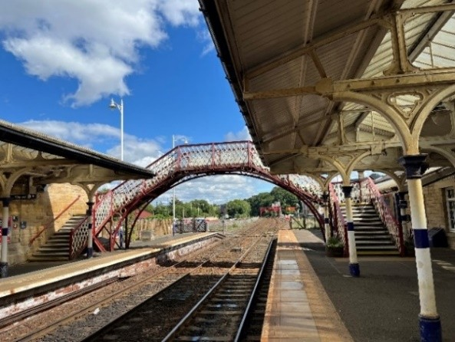  Figure 10: The foot bridge provided at Hexham to change platforms | 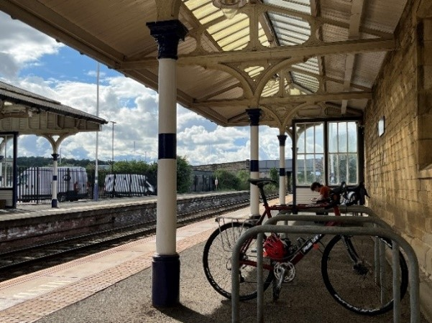  Figure 11: Shelter Platforms at the station |  |  | 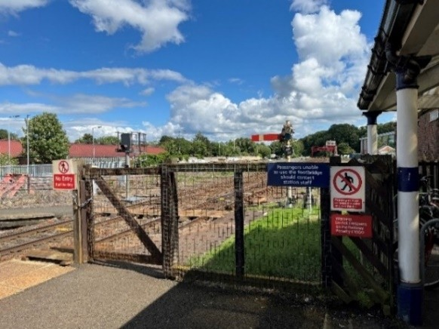  Figure 12: Signage requesting those passengers who are unable to utilise the footbridge to contact staff
Key observations
- Passengers advised they often approach station staff, when available, for questions about their journey or general queries regarding tickets, platforms and updates on cancellations and delays.
- Where station staff are not availble, passengers advised they often seek assistance from café and security staff who could only verbally support given they are not verified to assist with crossings.
- Peak hours for this station are in the morning due to the combination of commuters, sixth form and secondary school students utilising the service.
- The station has a Customer help point and Meeting Point.
- The TVMs were located under a sheltered part of the platform shown in Figure 13.
Customer Views
At this station, 13 respondents were spoken to of which the views are summarised:
- The majority of the respondents either use ‘Train Pal’, Trainline, the Northern app or TVM to purchase tickets.
- Respondents commented positively on the cleanliness of the station and the signage so that visitors can find their way.
- A respondent with a pram finds the accessibility at the station adequate and was not troubled by the extra walk required (via the bridge), as well as finding that usually the staff are present to help her onto the train with the pram.
- Multiple respondents found that the staff are very helpful and favoured interacting with staff to seek informational assistance from them.
- A few respondents mentioned that should they need assistence from the Ticket office, they did so due to being unable to purchase a particular type of ticket via the TVM, finding the staff easily accessible, or not having a card to purchase tickets from the TVM .
- One respondent mentioned struggles with the stairs but prefers not to trouble the staff. He mentioned that there will be a time at which he expects the stairs will become unmanageable.
- It was observed during the visit that a customer attempted to purchase a ‘promise to pay’ ticket but the machine did not work.
- There were several concerns about drunk people on Saturday nights as possibleincrease in anti-social behaviour at the station if it is fully unstaffed (including graffiti and arson).
- Multiple respondents reported that they felt it is beneficial to have staff to provide assistance, that it’s a shame the staff are being reduced, and that it’s important for the company to engage with people and provide information.
Figure 13: Two TVMs sheltered under a platform
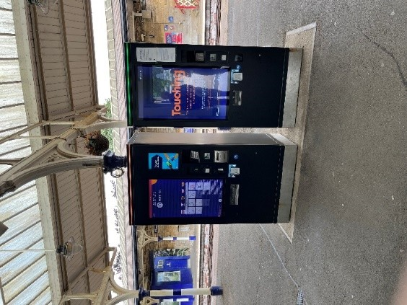

Station specific mitigations for Hexham are identified in Appendix A and Appendix C Station Specific mitigations (Hexham).

8.2 Harrogate Station
Introduction
Harrogate station, East of England, in North Yorkshire had a footfall of 1,211,846 between April 2021 and March 2022. The station has an A accessibility classification. The Ticket Office here is proposed to remain. Upon the visit, the station was affected by a signal failure, following the second day of the Great Yorkshire show, and staff were providing information and guidance to passengers who were experiencing delays and cancellations as well as giving directions to the show. The station has a waiting room which appeared to have a high level of cleanliness, with leather sofas, plugs and water refill stations, pictured in Figure 19. In addition, the stations had CCTV and lifts to access the bridge to cross platforms as shown in Figure 14 and Figure 17
Key observations
- The station receives of numerous accessibility requests from passengers who use wheelchairs, are elderly and are visually impaired.
- During the visit, there were always two people behind the ticket counter, plus around 6 members of staff standing by the ticket gates.
- Staff had noted that the number of commuters using the station had increased but Harrogate also receives people visiting for the day which increases demand to meet accessibility needs and answer questions.
- This station had many respondents that purchased tickets online but multiple respondents seeking assistance with further queries from the Ticket Office staff.
- All the platforms have both lifts and ramps available as well as wheelchairs available upon request (as pictured in Figure 15 and 14). There are sheltered TVMs that have touch screens and live video assist on both sides of the platform.
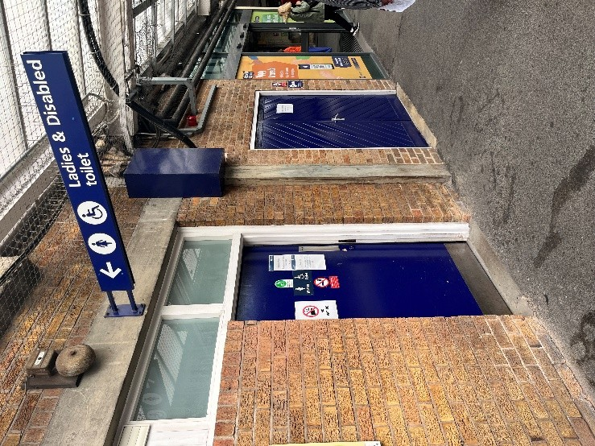  Figure 16: Signage to the Accessible Toilet | 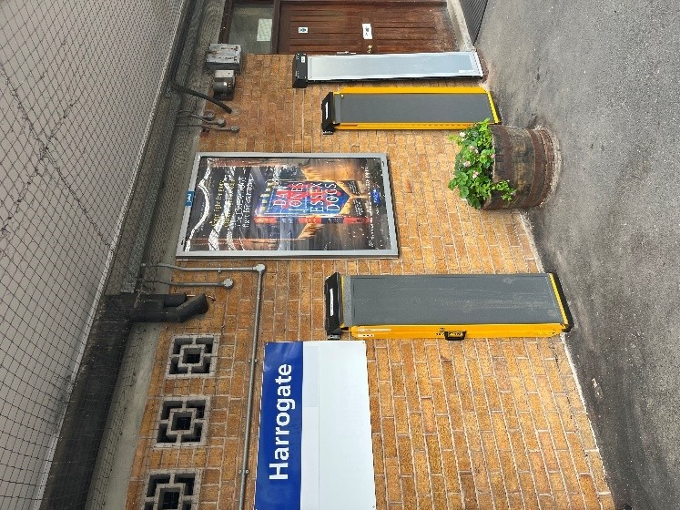  Figure 15: Ramps visible to assist passengers | 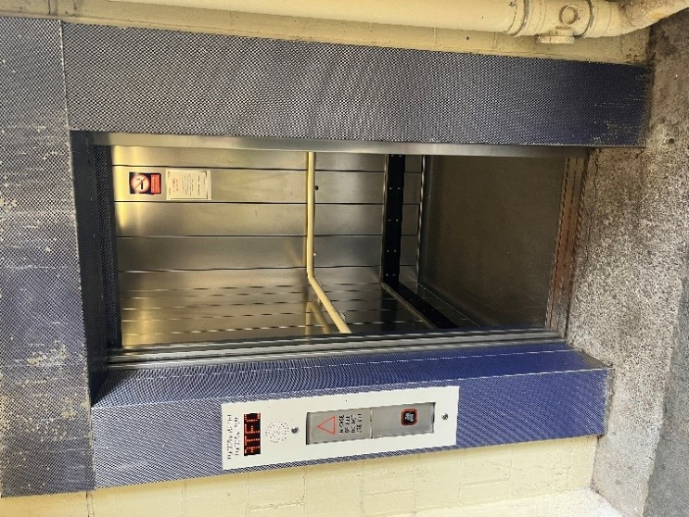  Figure 14: Lifts available to access the platform
Customer Views
At this station 15 respondents were spoken to of which the views are summarised:
- Most respondents bought their tickets online either via the Trainline or LNER app or via a TVM. Within this group, people either do not interact with TOs at all or seek assistance regarding queries (e.g., which trains their ticket is valid for and confirm timings of their tickets).
- Multiple customers were aware of Passenger Assist due to either using it for a relative or a friend. They reported a positive experience with it being easy to navigate with lots of staff ready to help. One respondent reported that Passenger Assist makes her feel more confident about travelling with her relative that requires assistance (see Figure 18).
- Respondents in need of a lift (due to mobility restraints or heavy luggage) reported ease of navigating this station and their only need to interact with staff was for help getting through the wide gates.
- Multiple respondents mentioned their usage of Trainline for further information regarding train fares and further train time information as oppose to the Ticket Office.
- Multiple respondents expressed a desire to only pay by cash, while others said they would request aid from their relatives in purchasing an online ticket, therefore, it would still be possible if the Ticket Office were to be closed. While one customer only utilised the Ticket Office this one time due to the need to purchase a ‘duo’ ticket, they were not certain this was possible via the TVM or online.
- One respondent complained of a lack of visual cues indicating the ‘wide gate,’ including those with prams or luggage. This resulted in a backlog when they initially attempted to pass through the standard gates.
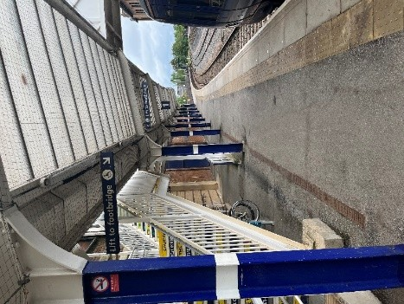  Figure 17: Directional signage to the footbridge | 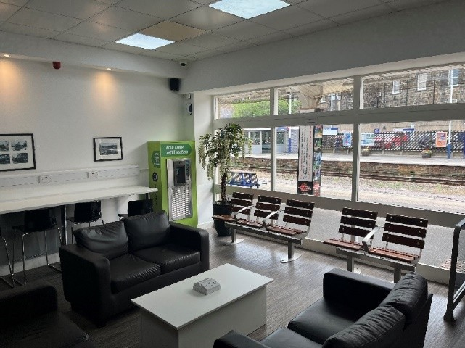  Figure 19: Waiting room with water refill, plugs and sofas | 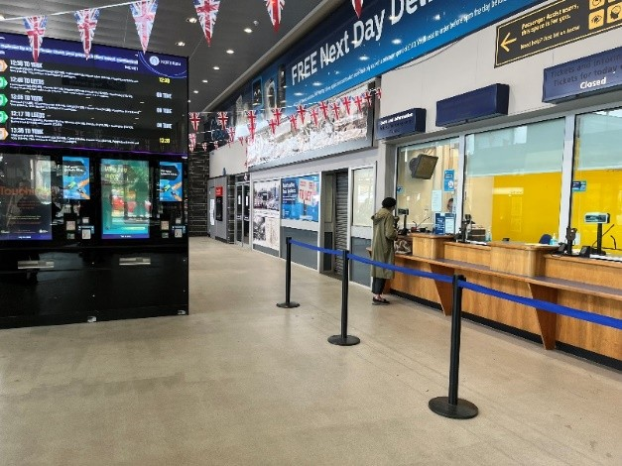  Figure 18: Ticket offices and signage to the Passenger Assist space
Station specific mitigations for Harrogate are identified in Appendix A and Appendix C Station Specific mitigations (Harrogate).

8.3 Manchester Victoria Station
Introduction
Manchester Victoria Station, Central England had a footfall of 237,100 between April 2021 and March 2022. The station has an A accessibility classification and has step-free access to all platforms. There are sheltered waiting areas on the platforms and all 4 platforms have accessibility ramps to aid any passenger that require assistance onto or from the train, as pictured in Figure 20. There are 4 TVMs at the station with accessible-friendly assistance on the hardware as picture in Figure 21. There is access to all platforms by lift as shown in Figure 22. There is one toilet area in the station (including an accessible toilet), located in the main area of the station near one of the entrances. There is CCTV monitoring throughout the station. A defibrillator is llocated in the main station area and is locked per protocol.
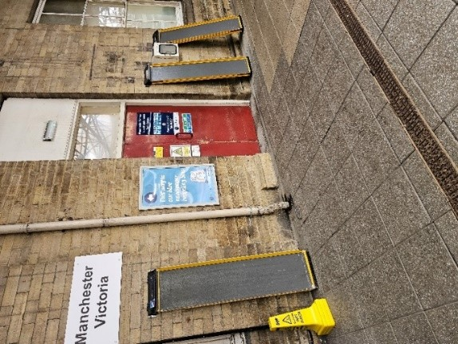  Figure 20: Several Accessibility ramps present on platform | 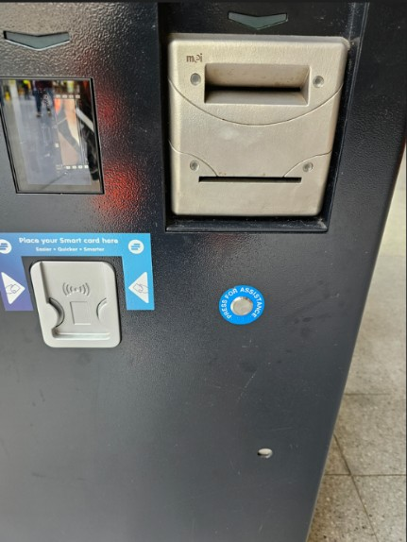  Figure 21: Help button with braille present on the TVM hardware itself | 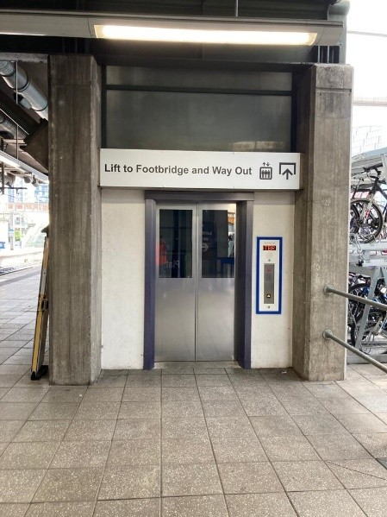  Figure 22: Lift access to platforms

Key Observations
- The station staff have noted very infrequent Passenger Assist requests, the majority were pre-booked. It was noted many people who travel through the station to/fromfrom Manchester Airport who require Passenger Assist services do so to make sure there is sufficient space and seats on the train.
- It was advised TVMs at these stations are typically utilised for collections rather than ticket purchasing (pictured in Figure 23). TVMs at this station have an accessibility-friendly assistance / help button on the hardware itself; hence, passengers with visual impairments can also access the services as needed (pictured in Figure 21). A number of options - such as video-assist, multi-language information, text-to-speech aid, option to lower the screen etc are available at the TVM.
Customer views
At this station, 25 respondents were spoken to of which the views are summarised:
- The majority of the respondents interviewed already either purchase online via Trainline or via the TVM. One respondent that had used the TVMs for the first time today found them user friendly and “easy enough.”
- There were positive reviews of the staff from majority of respondents, with many mentioning them being easy to find and always around to help
- Multiple respondents mentioned that they were either aware of or had used the Passenger Assist service. The signposting is visible in Figure 24.
- The few respondents that solely utilised Ticket office and physical tickets found that the TVMs are not user friendly, since they do not show all ticket types or routes, they find are inconsistent with Ticket Officer options. Others were concerned that TVMs do not always have cash options, have issues with certain cards, and can not help with issues with railcards and were subseuquently concerened about receiving penality fines in the future if unable to use the Ticket office
- A minority of respondents mentioned that the staff were difficult to locate and hardly saw them on the platform but were friendly when they interacted with the staff.
- Multiple respondents mentioned that they found there was a lack of toilets on the platforms.
A respondent mentioned that an alternative communication method about technical disruptions or network issue could be done so through either the website, app or SMS.
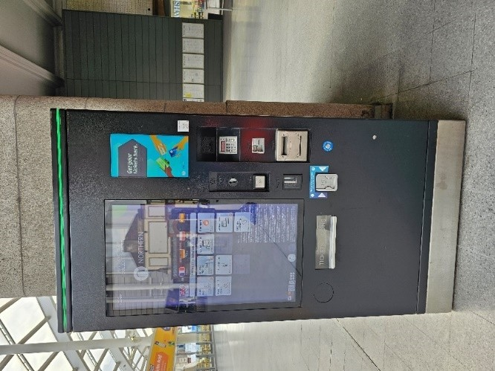  Figure 23: TVM | 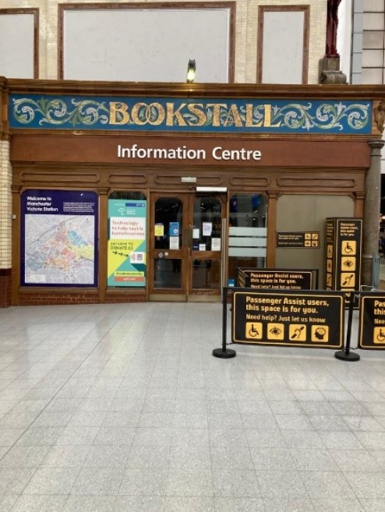  Figure 24: Information centre with PA

Station specific mitigations for Manchester Victoria are identified in Appendix A and Appendix C Station Specific mitigations (Manchester Victoria).

8.4 Meadowhall Station
Introduction
Meadowhall Station, Sheffield, had a footfall of 1,344,910 between April 2021 and March 2022. The Ticket Office here is planned to be closed during Phase 2 of the project. The station has an A accessibility category, with ramps present at every platform and is mobility scooter friendly. The station has one accessible toilet, located in the waiting room (pictured in Figure 27), which at the time of the site visit was out of order due to vandalism the previous day.
The accessible toilet and TVMs are located in waiting area on Platform 1.. There is a defibrillator located on Platform 2. The station have CCTV.
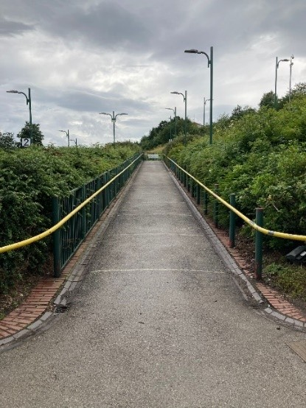  Figure 25: Ramp to Platform | 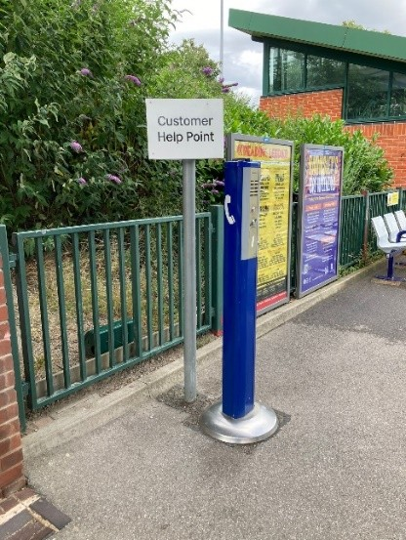  Figure 26: Customer Help point | 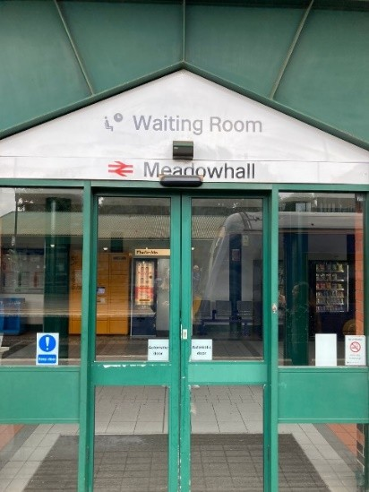  Figure 27: Waiting room in which the accessible toilet and TVMs are located

Key Observations
- Most passengers interviewed expressed opposition to the planned Ticket Office closure and indicated they would want increased staff presence around the station – it would be preferable if it was the Ticket office staff as most passengers would reach out to the Ticket office in case of any help required.
- Braille maps are in progress and will be rolled out soon but are not currrently available.
- The accessible toilet located in the waiting room was closed upon visit due to a vandalisation that occurred the night before. There is another accessible toilet located slightly further away.
Customer views
At this station, 16 respondents were spoken to of which the views are summarised:
- Those who utilised the station services more regularly (>4 times a week) tended to be more familiar and confident with the online services in which to purchase tickets. These respondents were more ambivalent regarding the closure of Ticket offices.
- Multiple respondents expressed their positive views of Meadowhall station, either through a personal experience or an example in which a member of staff has aided another customer regarding health and safety at the station. One respondent with a physical disability had used the Passenger assist service and was quite satisfied.
- Multiple respondents mentioned that feelings of safety at the station is directly associated to the presence of the staff.
- Some respondents noted the lack of clear signage and help points. Difficulty was experienced in navigating to Platforms 3 and 4 as they are located further away from the Ticket office than Platforms 1 and 2. However, some respondents expressed no difficulty with the signage and navigating around the station.
- Many respondents, irrespective of age, expressed negative views about the Ticket Officer closure and two have signed a petition against it. Respondents regarded staff presence as important for both safety and convenience reasons.
- Respondents that were older or used the station services less frequently (<1 a week) expressed greater attachment to the in-person services.
- In regard to the TO closures, there were several concerns raised by respondents regarding those with physical disabilities if there are a lack of staff present to provide assistance
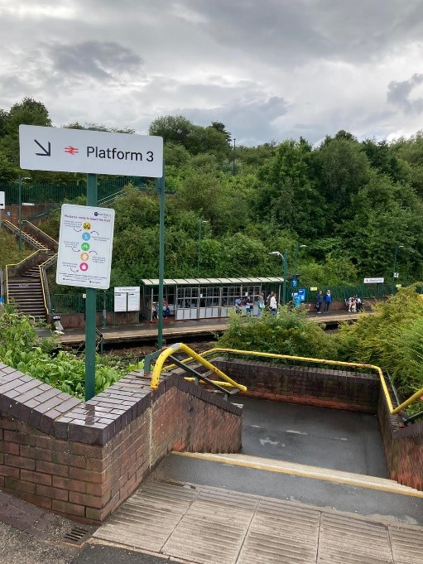  Figure 28: Signage to Platform 3 |  |  | 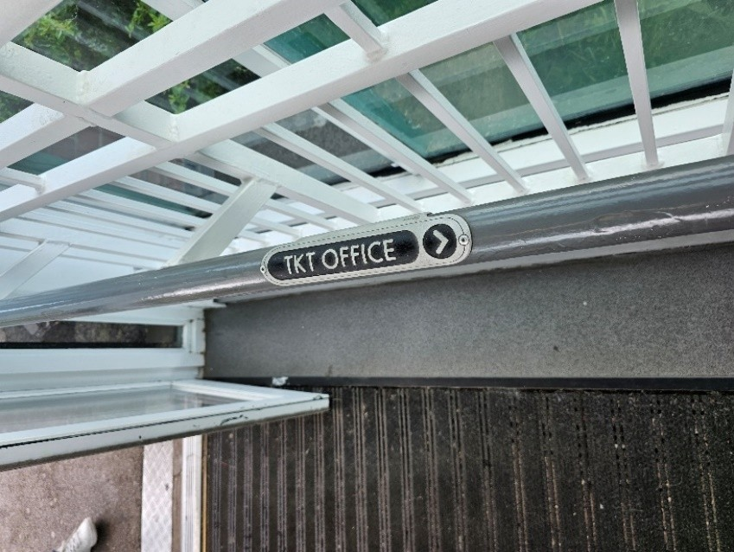  Figure 29: Braille signage on platform towards the TOs
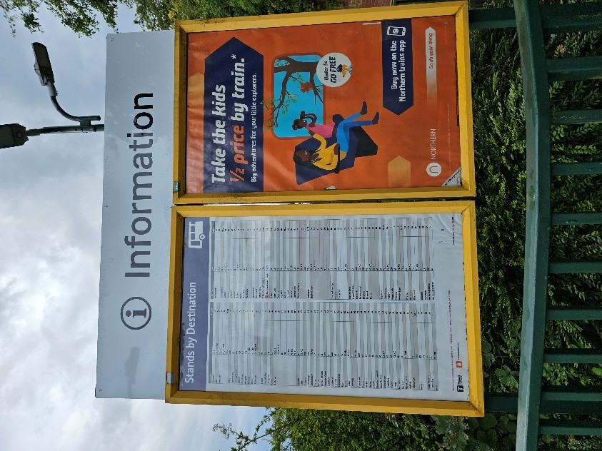  Figure 30: Information board with train times |  | 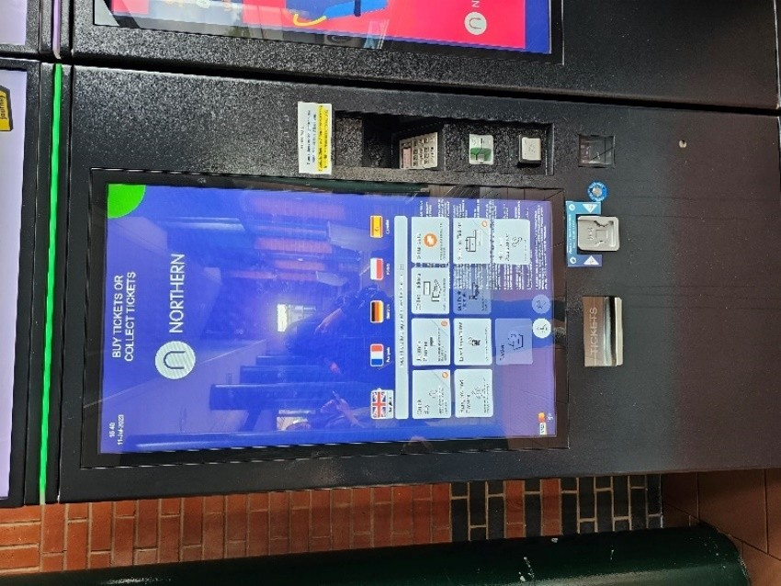  Figure 31: Ticket Vending Machine

Station specific mitigations for Meadowhall are identified in Appendix A and Appendix C Station Specific mitigations (Meadowhall).

9. Summary of Analysis

The following summarises the findings through the lens of the three aims of equality analysis. This provides a synthesis of the overarching impacts of the proposed policy. Checkmarks () denote positive impacts, whereas crosses () denote negative impacts. The approach to mitigations is documented in Section 10, along with supporting Appendices.
Policy sections and elements | PSED Aim 1: Eliminating Unlawful Discrimination | PSED Aim 2: Advancing Equality of Opportunity | PSED Aim 3: Fostering Good Relations
Closure of ticket offices and the introduction of the JM role | - Some TVMs may not be accessible for wheelchair users, as the screens are above seated level. This may impact on their ability to purchase tickets and therefore may exclude them from rail transport.  - Some passengers at barrow crossings maybe unable to access platforms if station staff and/or Journey makers are not available to support the request  - Some passengers who use “turn up and Go” who have not pre-booked Passenger Assist may experience a decrease in service as ticket office staff or journey makers are not available to support the need | - The JM tablets will have enhanced accessibility features (e.g., audio function, translation ability), enabling staff to better assist disabled people  - Subject to funding proposals, a number of mitigation activities are planned which will strengthen existing accessibility measures at stations (refer to Appendix A, Appendix C)  - Additional retail channels will provide customers with more opportunity to purchase tickets away from the Ticket Office, including those who prefer to pay with cash, subject to funding proposals. Third party retailers will in most cases be open for longer than the current ticket office provision (refer to Appendix A, Appendix C)  - With the removal of the ticket office staff, this may impact on certain groups of customers (e.g., those who are pregnant, mobility-impaired people) who require assistance (e.g., ramps, access to toilets).  - Some groups (e.g., the elderly) who are more likely to feel digitally excluded, or whose preference is cash as their payment method, may feel dissuaded or excluded from accessing rail transport.  - There may be decreased perceptions of safety from certain groups (e.g., women, LGBTQ+, disabled, ethnic minorities, religious minorities) – particularly those who are more vulnerable to hate crimes – due to the reduced hours of staff at stations. | - Some customers (e.g., LGBTQ+, women, ethnic minorities) may feel more comforted by the fact there isn an enhanced station presence on platform when Journey Makers are present.  - Journey Makers will provide an enhanced customer service, when available on the platform
Policy sections and elements | - PSED Aim 1: Eliminating Unlawful Discrimination | - PSED Aim 2: Advancing Equality of Opportunity | PSED Aim 3: Fostering Good Relations
Access to station facilities | - Subject to funding proposals, a number of mitigation activities are planned which will strengthen existing accessibility measures at some stations (refer to Appendix A, Appendix C)  No negative impacts identified | - Subject to funding proposals, a number of mitigation activities are planned which will strengthen existing accessibility measures at some stations (refer to Appendix A, Appendix C). In most cases this will mean facilities are open for longer.  - With the reduction of hours where station staff are present, this may impact on some groups’ perception of safety | No impacts identified

10. Mitigation approach

In Section 7 - Potential Impacts the Equality Analysis identified a number of impacts to the proposed policy examined in this Impact Assessment. Specific stations were sampled in Section 8 - Case Studies and in Section 9 - Summary of Analysis, a summary of findings are documented through the lens of the three aims of equality analysis.
A public consultation is underway and this Equality Analysis and mitigations will continue to evolve throughout any subsequent funding, delivery, and implementation. In the interim, Northern has identified proposed mitigations to Ticket Office closures in the following way:
Appendix | Purpose | Reference to potential impacts
Appendix A | This section documents the general mitigations that cover a wide range of Northern’s existing and proposed customer offerings but are not specific solely to the proposed changes to ticket offices.  They provide business wide enhancements to the Northern customer experience and a number of these are complimentary to the specific station mitigations in Appendix C | The Appendix provides additional mitigation to Section 7 - Potential Impacts identfied and Section 9 - Summary of Analysis sections and elements of the Equality Analysis.
Appendix B | This appendix contains the breakdown of the impact on the protected charactersitcs at each station, alongside the station abbreviation, step free access categorisation and the IMD rank. | The appendix provides visibility on the Protected Characteristics that are disproportionately affected by the station borough are categoried as N (Negative)
Appendix C | This appendix contains 149 specific station dashboards.  These dashboards provide a focused view of the affected Protected Characteristics impacted at the specific station (as identified in Section 7 - Potential Impacts, Section 8 - Case Studies, Section 9 - Summary of analysis and the mitigations Northern are proposing for each station.  Each station dashboard contains a full list of numbered Mitigation references, designed to show how particular mitigations are applied at each impacted station.  These numbered references link directly to Appendix D where a full description of the mitigation, and it’s rationale is provided.  Station Ticket Office Closure Mitigations have been split into two categories (mitigation implemented or planned subject to final consutlation) providing transparency on status. | As detailed in Appendix B, the Protected Characteristics that are disproportionately affected by the station borough are categorised as N (Negative). Those Protected Characteristics that are either neutrally or positively affected by certain initiatives or station infrastructure are categorised as P (Positive)  The ratings were implemented by conducting an analysis on the infrastructure of each station and which protected characteristics these features impacted the most. Further station attributes including anti-social behaviour and protected characteristics initiatives were also considered in the analysis.
Appendix D | To provide the reader with a greater understanding of the Station Ticket Office Closure Mitigations in Appendix D, Northern have developed a number of definitions and supporting rationale.  These provide a fuller description of the mitigation refrenced in Appendix D, and a rationale as to why this is a mitigation in this instance. | N/A

Appendix A - General Improvement Mitigations

These general mitigations cover a wide range of Northern’s existing and proposed customer offerings but are not specific solely to the proposed changes to ticket offices. They provide business wide enhancements to the Northern customer experience and a number of these are complimentary to the specific station mitigations in Appendix C and provide additional mitigation to Section 7: Potential Impacts, Section 9: Summary of Analysis and other elements of the Equality Analysis.
Mitigation Title | Mitigation Definition | Mitigation Rationale
Existing Customer Policies | As set out in detail the Section 3: Customer PoliciesSection 3: Customer Policies of this report, Northern has committed to provide accessible rail services to all customers and to support the communities in which we operate. We also regularly review and evaluate the impact of our Accessible Travel Policies  - Key offerings for older and disabled customers include:  - Assistance at stations and on trains, including when making connections.  - Alternative accessible transport in case of inaccessibility at stations or on trains.  - Clear, consistent, and up-to-date customer information (in both aural and visual form, shared through ‘Making rail accessible’ leaflet, Customer Experience Centre, Ticket Offices, public address systems on trains and website).  Noted in Section 3 in particular relating to the Station facilities are;  - Passenger Assist Facility: Northern provides access to an industry-wide booking assistance platform called Passenger Assist. Customers can use the system at any time to book assistance at stations during their journey and they can also book assistance to board and alight trains.  - Accessibility and Inclusivity for All (AlfA): We are improving our stations and the experience of customers and our people through the Accessibility and Inclusivity for All (AIfA) programmes. Depending upon station survey results (e.g. existing facilities / condition), the following will either be renewed or a new asset installed.  - PA induction loops  - Help points  - Station maps  - Braille maps  - Station signage / wayfinding  - Existing toilet upgrade  - New POD install  - Handrails repair / paint  - Stair nosings and tactiles – repair / paint  - Seating – repair / paint / replace  - Shelters – repair / paint / replace  - Drop off shelters  - Car park works, repair and reline  - Door mats – repair / replace  - Replace cycle shelter  - Footpath / drop kerb improvements / ramps  - Platform overlays (reducing the distance between the platform and the train) | Emphasis is placed on enabling older and disabled passengers to travel with confidence. The provision of services to these customers is embedded in business and project planning, and training is offered to employees to ensure they have the right resources, skills, and confidence to deliver appropriate assistance.
Retail Channels | Retail Channels are set out in section 4.2 Retail Channels  Customers will be supported by ‘Journey Makers’ and will have access to a range of retail options including the option to purchase tickets with cash. | At the point at which Northern closes the proposed tickets offices, the full range of our products which currently retail in ticket offices will be available digitally therefore customers will still have access to purchase products currently sold in Ticket Offices.  Customers who prefer to pay in cash can continue to do so.
Conductor | Conductors will continue to perform assistance wherever it is requested by a customer, will retail tickets to customers with Promise to Pay, and will have the benefit of being able to see all booked assistance through the Transreport app. Will also have a live view of TVM status to see where TVMs may be out of use. | This mitigates the risk to Turn Up and Go (TAUG) assistance delivery by ensuring there is always a staff member available to provide support in boarding/alighting the service and mitigates risk of unnecessary penalty fares being issued.
Travel safe officers | Roving team of security staff providing additional security on the network. | Prevents antisocial behaviour on the network and allows us to respond to repeat incident locations. Reduces risk of hate crime when visible on the network.
Revenue protection officers | Unaffected Train/station-based staff | Will provide visible staff across the network to support customers and deter anti-social behaviours.
Social media (Twitter/Instagram) | Our Social Media teams will support customers throughout proposed changes. | Our social media teams will be briefed to provide additional support for customers as proposed changes come into effect.
Safety campaigns | We will launch/extend safety campaigns related to hate crime and unwanted sexual behaviour. | Provides publicity to drive down rates of crime and anti-social behaviour.
Customer support campaign | Marketing campaign to support customers through the changes being made by the current proposals | Provides guidance for customers who may need additional support in travelling during the early phases of the proposed changes.
Sign-live | British Sign Language (BSL) live translation subscription service. | Will allow for direct communication with primary BSL communicators via the interpreter service using Journey Maker tablet device or smartphone.
Google Translate – Journey Maker Tablet | Journey Marker Smart Devices will allow for the use of Google Translate to facilitate communication in languages other than English. | Enhances the ability of our Customer Service staff to engage with a wider range of customers.
WhatsApp - automated journey related messaging | A Northern WhatsApp account with Chatbot AI to provide smart device-based journey planning and support for customers. | Mitigates the risk of passengers being unable to find onward accessible transport without the presence of station staff. Allows for human-style interaction which can replicate aspects of customer service support, primarily around journey planning but to be developed further.
RDG Smarter Information and Smarter Journey Programme | An industry wide initiative to improve customer information at various parts of a journey, from booking tickets, to experience on-board the train. | Ensures customer information is more accessible, more useful, and available more consistently, reducing the risk of confusion when travelling and if experiencing disruption.

Appendix B – Station to Protected Characteristic Mapping

B.1 Affected Protected Characteristics
As outlined in Section 5 – Methodology the main body of the EQIA Report, the Protected Characteristics that are disproportionately affected by the station borough are categorised as N (Negative). Those Protected Characteristics that are either neutrally or positively affected by certain initiatives or station infrastructure are categorised as P (Positive). The ratings were implemented by conducting an analysis on the infrastructure of each station and which protected characteristics these features impacted the most. Further station attributes including anti-social behaviour and protected characteristics initiatives were also considered in the analysis.
Affected protected characteristics | P (Positive impact) | N (Negative impact)

B.2 Index of Multiple Deprivation
As outlined in Section 5 - Methodology of the main body of the EQIA Report, an IMD score has been calculated for each borough of the impacted Station, which is captured in the Station Mitigation Dashboards. The Index of Multiple Deprivation (IMD) is a measure of relative deprivation for small areas. The IMD scores for each local authority shows the larger the score, the more deprived the area.

B.3 Step Free Access
Each station dashboard has the current step free access rating. The mitigation table will capture whether there are any planned improvements being made to the step free access category at impacted stations.
Step free access | A: Step free access to all platforms via level crossings, lifts, ramps.  B1: Step free access to all platforms – may include long or steep ramps. Access between platforms may be via the street.  B2: Some step free access to all platforms.  B3: Some step free access, may be in one direction only.  C: The station has no step free access to any platform.

B.4 Station to Protected Characteristics mapping output

Station name | Abbreviation | Age | Disability | Sex | Ethnicity | Religion | Sexual Orientation | Pregnancy and Maternity | Gender reassignment | Marriage and Civil Partnerships | Step Free Access | IMD Score
Accrington | ACR | N | N | P | N | N | N | N | N | P | B2 | 34.333
Adlington (Lancashire) | ADL | N | N | P | P | P | P | N | P | P | B1 | 16.863
Alderley Edge | ALD | N | N | P | P | P | P | N | P | P | B2 | 14.475
Alnmouth | ALM | N | N | P | P | P | P | N | P | P | A | 22.079
Appleby | APP | P | N | P | P | P | P | N | P | P | B2 | #N/A
Ashton-Under-Lyne | AHN | P | N | N | N | N | N | P | N | P | B2 | 31.374
Atherton | ATN | N | N | P | P | P | P | P | P | P | A | 25.713
Barnsley | BNY | N | P | P | P | P | P | P | P | P | A | 29.933
Barrow-In-Furness | BIF | N | N | P | N | N | N | N | N | P | A | #N/A
Beverley | BEV | P | P | P | P | P | P | P | P | P | B1 | 31.335
Bingley | BIY | N | P | P | P | P | P | P | P | P | B2 | 34.666
Birchwood | BWD | N | N | P | N | N | N | N | N | P | B2 | 18.942
Blackburn | BBN | N | P | N | P | P | N | N | N | P | A | 36.013
Blackpool North | BPN | P | P | P | P | P | P | P | P | P | A | 45.039
Bolton | BON | N | N | N | N | N | N | N | N | P | A | 30.691
Bradford Forster Square | BQD | N | N | P | P | P | P | P | P | P | A | 34.666
Bradford Interchange | BDI | P | P | P | P | P | P | P | P | P | A | 34.666
Bramhall | BML | N | N | P | P | P | P | N | P | P | B3 | 20.826
Bredbury | BDY | N | N | P | P | P | P | N | P | P | C | 20.826
Bridlington | BDT | N | P | P | P | P | P | N | P | P | B3 | 31.335
Brinnington | BNT | N | P | P | N | N | N | P | N | P | C | 20.826
Broad Green | BGE | P | P | P | P | P | P | P | P | P | B2 | 42.412
Broadbottom | BDB | P | P | P | P | P | P | P | P | P | B3 | 31.374
Bromley Cross | BMC | P | P | P | N | N | P | N | N | P | B2 | 30.691
Buckshaw Parkway | BSV | N | N | P | P | P | P | N | P | P | A | 16.863
Burnage | BNA | P | P | N | N | N | N | P | N | P | B2 | 40.005
Burnley Central | BNC | N | N | P | P | P | P | N | P | P | A | 37.793
Burnley Manchester Road | BYM | N | N | P | P | P | P | N | P | P | B3 | 37.793
Buxton | BUX | P | N | P | N | N | N | P | N | P | A | 15.642
Chassen Road | CSR | P | P | P | P | P | P | P | P | P | B1 | 16.088
Cheadle Hulme | CHU | P | P | N | N | N | N | P | N | P | B1 | 20.826
Chorley | CRL | N | N | P | P | P | P | N | P | P | B1 | 16.863
Congleton | CNG | N | P | P | P | P | P | N | P | P | B1 | 14.475
Cross Gates Yorks | CGR | P | P | P | N | N | N | P | N | P | B2 | 27.301
Daisy Hill | DSY | N | N | P | P | P | P | N | P | P | C | 30.691
Davenport | DVN | N | N | P | P | P | P | N | P | P | C | 20.826
Deansgate | DGT | N | N | P | P | P | P | N | P | P | A | 40.005
Dinting | DTG | P | P | P | P | P | P | P | P | P | A | 15.642
Disley | DSL | P | P | P | P | P | P | P | P | P | B1 | 14.475
Driffield | DRF | N | N | P | P | P | P | N | P | P | B2 | 31.335
Earlestown | ERL | N | N | P | P | P | P | N | P | P | B3 | 31.518
East Didsbury | EDY | P | P | P | N | N | N | P | N | P | B2 | 40.005
Eccles | ECC | N | N | P | P | P | P | P | P | P | C | 34.210
Eccleston Park | ECL | N | N | P | P | P | P | N | P | P | B2 | 31.518
Edge Hill Liverpool | EDG | N | N | P | P | P | P | N | P | P | B3 | 42.412
Farnworth | FNW | P | P | P | P | P | P | P | P | P | B2 | 30.691
Flixton | FLI | P | P | P | P | P | P | P | P | P | B2 | 16.088
Garforth | GRF | N | N | P | P | P | P | N | P | P | B3 | 27.301
Garswood | GSW | N | N | P | P | P | P | N | P | P | B3 | 31.518
Gatley | GTY | P | P | N | N | N | N | P | N | P | B2 | 20.826
Glazebrook | GLZ | N | N | P | P | P | P | P | P | P | B3 | 18.942
Glossop | GLO | P | N | P | N | N | N | P | N | P | A | 15.642
Goole | GOO | N | N | P | P | P | P | N | P | P | A | 31.335
Gorton | GTO | P | P | P | P | P | P | P | P | P | B1 | 40.005
Grange-Over-Sands | GOS | P | P | P | P | P | P | P | P | P | A | #N/A
Greenfield | GNF | N | N | P | N | N | N | P | N | P | B3 | 33.155
Guide Bridge | GUI | P | P | P | P | P | P | P | P | P | B2 | 31.374
Guiseley | GSY | N | N | P | N | N | N | N | N | P | B2 | 27.301
Hadfield | HDF | P | P | P | N | N | N | P | N | P | A | 15.642
Hag Fold | HGF | P | P | P | P | P | P | P | P | P | B2 | 25.713
Hale | HAL | P | P | P | N | N | N | P | N | P | B2 | 16.088
Halewood | HED | P | P | P | N | N | N | P | N | P | B2 | 43.006
Halifax | HFX | P | N | P | P | P | P | N | P | P | A | 26.351
Handforth | HTH | N | N | P | P | P | P | P | P | P | C | 14.475
Harrogate | HGT | P | P | P | P | P | P | N | P | P | A | #N/A
Hartlepool | HPL | N | N | P | P | P | P | N | P | P | A | 35.037
Hattersley | HTY | N | N | P | N | N | N | P | N | P | C | 31.374
Hazel Grove | HAZ | P | P | P | N | N | N | P | N | P | A | 20.826
Heald Green | HDG | P | P | P | N | N | N | P | N | P | B2 | 20.826
Heaton Chapel | HTC | P | P | P | P | P | P | P | P | P | B1 | 20.826
Hebden Bridge | HBD | N | N | P | P | P | P | N | P | P | A | 26.351
Hexham | HEX | N | N | N | P | P | P | N | P | P | B2 | 22.079
Hindley | HIN | N | N | P | P | P | P | P | P | P | C | 25.713
Holmes Chapel | HCH | N | P | P | P | P | P | P | P | P | B2 | 14.475
Horsforth | HRS | N | N | P | P | P | P | N | P | P | B1 | 27.301
Hough Green | HGN | P | P | P | N | N | N | P | N | P | B3 | 32.325
Huyton | HUY | N | N | P | N | N | N | N | N | P | A | 43.006
Ilkley | ILK | N | N | P | P | P | P | N | P | P | A | 34.666
Keighley | KEI | P | P | P | P | P | P | P | P | P | A | 34.666
Kirkham & Wesham | KKM | N | N | P | P | P | P | N | P | P | A | 15.875
Knutsford | KNF | P | P | P | P | P | P | P | P | P | B2 | 14.475
Lea Green | LEG | P | P | P | P | P | P | P | P | P | B2 | 31.518
Leeds | LDS | N | N | P | P | P | P | P | P | P | A | 27.301
Levenshulme | LVM | N | N | P | N | N | N | N | N | P | C | 40.005
Leyland | LEY | N | N | P | N | N | N | N | N | P | A | 15.330
Littleborough | LTL | P | P | P | P | P | P | P | P | P | B1 | 34.415
Liverpool Lime Street | LIV | N | N | P | P | P | P | N | P | P | A | 42.412
Lostock Parkway | LOT | P | P | P | P | P | P | P | P | P | B1 | 30.691
Manchester Oxford Road | MCO | N | N | P | P | P | P | N | P | P | A | 40.005
Manchester Victoria | MCV | N | N | P | P | P | P | N | P | P | B1 | 40.005
Marple | MPL | N | N | P | P | P | P | N | P | P | A | 20.826
Mauldeth Road | MAU | P | P | P | N | N | N | P | N | P | B2 | 40.005
Meadowhall | MHS | N | N | P | P | P | P | N | P | P | A | 27.060
Menston | MNN | P | P | P | P | P | P | N | P | P | B2 | 34.666
Mexborough | MEX | N | N | P | P | P | P | N | P | P | A | 30.289
Morecambe | MCM | P | P | P | P | P | P | N | P | P | A | 24.165
Morpeth | MPT | N | N | P | P | P | P | N | P | P | A | 22.079
Mossley (Manchester) | MSL | N | N | P | P | P | P | P | P | P | B3 | 31.374
Mossley Hill | MSH | N | N | P | P | P | P | N | P | P | C | 42.412
New Mills Central | NMC | N | P | P | P | P | P | P | P | P | B3 | 15.642
New Mills Newtown | NMN | P | P | P | P | P | P | P | P | P | B1 | 15.642
New Pudsey | NPD | P | P | P | P | P | P | P | P | P | A | 27.301
Newton For Hyde | NWN | N | N | P | P | P | P | N | P | P | C | 31.374
Newton-Le-Willows | NLW | N | N | P | P | P | P | N | P | P | A | 31.518
Northwich | NWI | N | N | P | P | P | P | N | P | P | B3 | 18.083
Parbold | PBL | P | N | P | P | P | P | N | P | P | B1 | 18.645
Poulton-Le-Fylde | PFY | P | N | P | P | P | P | N | P | P | A | 20.858
Poynton | PYT | P | P | P | P | P | P | P | P | P | B1 | 14.475
Prescot | PSC | N | N | P | P | P | P | N | P | P | A | 43.006
Rainhill | RNH | P | N | P | P | P | P | N | P | P | B2 | 31.518
Redcar Central | RCC | N | N | P | P | P | P | N | P | P | B1 | 29.792
Reddish North | RDN | N | N | P | P | P | P | P | P | P | C | 20.826
Roby | ROB | N | N | P | P | P | P | P | P | P | A | 43.006
Rochdale | RCD | N | N | P | N | N | N | N | N | P | A | 34.415
Romiley | RML | N | P | P | P | P | P | N | P | P | B3 | 20.826
Rose Hill (Marple) | RSH | P | P | P | P | P | P | P | P | P | A | 20.826
Rotherham Central | RMC | N | N | P | P | P | P | N | P | P | A | 29.550
Salford Central | SFD | N | N | P | P | P | P | N | P | P | B2 | 34.210
Salford Crescent | SLD | N | N | P | P | P | P | N | P | P | A | 34.210
Sandbach | SDB | N | N | P | P | P | P | P | P | P | B3 | 14.475
Settle | SET | N | N | P | P | P | P | N | P | P | B2 | #N/A
Shipley | SHY | P | N | P | P | P | P | N | P | P | B2 | 34.666
Skipton | SKI | P | P | P | P | P | P | P | P | P | A | #N/A
St Annes-On-The-Sea | SAS | N | N | P | P | P | P | N | P | P | A | 15.875
St Helens Central | SNH | N | N | P | P | P | P | N | P | P | A | 31.518
St Helens Junction | SHJ | P | N | P | P | P | P | N | P | P | B3 | 31.518
Sunderland | SUN | N | N | P | N | N | N | N | N | P | A | 30.586
Swinton (Greater Manchester) | SWN | N | N | P | P | P | P | P | P | P | A | 34.210
Swinton (Yorks) | SNN | N | N | P | P | P | P | N | P | P | A | 29.550
Thatto Heath | THH | P | P | P | P | P | P | P | P | P | B1 | 31.518
Thorne North | TNN | N | N | P | P | P | P | N | P | P | B3 | 30.289
Todmorden | TOD | N | N | P | P | P | P | N | P | P | B3 | 26.351
Ulverston | ULV | P | P | P | N | N | N | P | N | P | B3 | #N/A
Urmston | URM | P | P | P | P | P | P | P | P | P | B2 | 16.088
Walkden | WKD | N | N | P | N | N | N | N | N | P | C | 34.210
Warrington Central | WAC | N | N | P | P | P | P | N | P | P | A | 18.942
Warrington West | WAW | N | N | P | P | P | P | N | P | P | A | 18.942
Wavertree Technology Park | WAV | N | N | P | P | P | P | N | P | P | A | 42.412
West Allerton | WSA | N | N | P | P | P | P | N | P | P | C | 42.412
Whaley Bridge | WBR | P | P | P | P | P | P | P | P | P | B2 | 15.642
Whiston | WHN | P | P | P | N | N | N | P | N | P | B2 | 43.006
Whitehaven | WTH | P | P | P | P | P | P | P | P | P | A | #N/A
Widnes | WID | P | P | P | P | P | P | P | P | P | B1 | 32.325
Wigan Wallgate | WGW | N | N | P | P | P | P | N | P | P | A | 25.713
Wilmslow | WML | P | P | P | N | N | N | P | N | P | A | 14.475
Windermere | WDM | P | N | P | P | P | P | N | P | P | A | #N/A
Woodsmoor | WSR | N | N | P | P | P | P | N | P | P | C | 20.826
Workington | WKG | N | N | P | P | P | P | N | P | P | C | #N/A
Worksop | WRK | N | N | P | P | P | P | N | P | P | B1 | 22.588

Appendix C - Station Mitigation Dashboards

In addition to the Station Environment Improvement Mitigations contained within Appendix A, Northern have developed Station specific dashboards contained within excel files. These dashboards provide a focused view of the mitigations Northern are proposing for that station. To provide the reader with a greater understanding of the Station Ticket Office Closure Mitigations, Northern have developed a number of definitions and rationale contained within Appendix D. Due to the size and scale of the network and stations there are varying types and number of mitigations proposed.
Each station dashboard contains a full list of numbered Mitigation references, designed to show how particular mitigations are applied at each station. These numbered references link directly to Appendix D where a fuller description of the mitigation, and it’s rationale as to why this is a mitigation, is provided. The station specific dashboard should be considered in conjunction with Appendix A. All current station facilities have an existing station page which can be found here: Train Stations | All Stations on Our Network | Northern (northernrailway.co.uk)

C.1 Mitigation Categories
In addition, Station Ticket Office Closure Mitigations have been split into two categories (see below), providing transparency on which mitigations are currently implemented and which are planned, subject to final consultation, at the specific station.
Mitigation Title | Mitigation Definition
Y | Mitigation Implemented
P | Mitigation planned subject to final consultation

C.2 Station Dashboard Files

The station mitigation dashboards have been split into 15 different excel files. The stations and files are in alphabetical order and contain 15 stations each, with the exception of Station Mitigations File 10 which contains 14.
The table below provides a list of the stations and which file the dashboard can be located in. Each file also has a cover sheet with hyperlinksto allow users to easily locate the dashboards.

Station name | Abbreviation | Excel File Name/Number
Accrington | ACR | Station Mitigations File 1
Adlington (Lancashire) | ADL | Station Mitigations File 1
Alderley Edge | ALD | Station Mitigations File 1
Alnmouth | ALM | Station Mitigations File 1
Appleby | APP | Station Mitigations File 1
Ashton-Under-Lyne | AHN | Station Mitigations File 1
Atherton | ATN | Station Mitigations File 1
Barnsley | BNY | Station Mitigations File 1
Barrow-In-Furness | BIF | Station Mitigations File 1
Beverley | BEV | Station Mitigations File 1
Bingley | BIY | Station Mitigations File 1
Birchwood | BWD | Station Mitigations File 1
Blackburn | BBN | Station Mitigations File 1
Blackpool North | BPN | Station Mitigations File 1
Bolton | BON | Station Mitigations File 1
Bradford Forster Square | BQD | Station Mitigations File 2
Bradford Interchange | BDI | Station Mitigations File 2
Bramhall | BML | Station Mitigations File 2
Bredbury | BDY | Station Mitigations File 2
Bridlington | BDT | Station Mitigations File 2
Brinnington | BNT | Station Mitigations File 2
Broad Green | BGE | Station Mitigations File 2
Broadbottom | BDB | Station Mitigations File 2
Bromley Cross | BMC | Station Mitigations File 2
Buckshaw Parkway | BSV | Station Mitigations File 2
Burnage | BNA | Station Mitigations File 2
Burnley Central | BNC | Station Mitigations File 2
Burnley Manchester Road | BYM | Station Mitigations File 2
Buxton | BUX | Station Mitigations File 2
Chassen Road | CSR | Station Mitigations File 2
Cheadle Hulme | CHU | Station Mitigations File 3
Chorley | CRL | Station Mitigations File 3
Congleton | CNG | Station Mitigations File 3
Cross Gates Yorks | CGR | Station Mitigations File 3
Daisy Hill | DSY | Station Mitigations File 3
Davenport | DVN | Station Mitigations File 3
Deansgate | DGT | Station Mitigations File 3
Dinting | DTG | Station Mitigations File 3
Disley | DSL | Station Mitigations File 3
Driffield | DRF | Station Mitigations File 3
Earlestown | ERL | Station Mitigations File 3
East Didsbury | EDY | Station Mitigations File 3
Eccles | ECC | Station Mitigations File 3
Eccleston Park | ECL | Station Mitigations File 3
Edge Hill Liverpool | EDG | Station Mitigations File 3
Farnworth | FNW | Station Mitigations File 4
Flixton | FLI | Station Mitigations File 4
Garforth | GRF | Station Mitigations File 4
Garswood | GSW | Station Mitigations File 4
Gatley | GTY | Station Mitigations File 4
Glazebrook | GLZ | Station Mitigations File 4
Glossop | GLO | Station Mitigations File 4
Goole | GOO | Station Mitigations File 4
Gorton | GTO | Station Mitigations File 4
Grange-Over-Sands | GOS | Station Mitigations File 4
Greenfield | GNF | Station Mitigations File 4
Guide Bridge | GUI | Station Mitigations File 4
Guiseley | GSY | Station Mitigations File 4
Hadfield | HDF | Station Mitigations File 4
Hag Fold | HGF | Station Mitigations File 4
Hale | HAL | Station Mitigations File 5
Halewood | HED | Station Mitigations File 5
Halifax | HFX | Station Mitigations File 5
Handforth | HTH | Station Mitigations File 5
Harrogate | HGT | Station Mitigations File 5
Hartlepool | HPL | Station Mitigations File 5
Hattersley | HTY | Station Mitigations File 5
Hazel Grove | HAZ | Station Mitigations File 5
Heald Green | HDG | Station Mitigations File 5
Heaton Chapel | HTC | Station Mitigations File 5
Hebden Bridge | HBD | Station Mitigations File 5
Hexham | HEX | Station Mitigations File 5
Hindley | HIN | Station Mitigations File 5
Holmes Chapel | HCH | Station Mitigations File 5
Horsforth | HRS | Station Mitigations File 5
Hough Green | HGN | Station Mitigations File 6
Huyton | HUY | Station Mitigations File 6
Ilkley | ILK | Station Mitigations File 6
Keighley | KEI | Station Mitigations File 6
Kirkham & Wesham | KKM | Station Mitigations File 6
Knutsford | KNF | Station Mitigations File 6
Lea Green | LEG | Station Mitigations File 6
Leeds | LDS | Station Mitigations File 6
Levenshulme | LVM | Station Mitigations File 6
Leyland | LEY | Station Mitigations File 6
Littleborough | LTL | Station Mitigations File 6
Liverpool Lime Street | LIV | Station Mitigations File 6
Lostock Parkway | LOT | Station Mitigations File 6
Manchester Oxford Road | MCO | Station Mitigations File 6
Manchester Victoria | MCV | Station Mitigations File 6
Marple | MPL | Station Mitigations File 7
Mauldeth Road | MAU | Station Mitigations File 7
Meadowhall | MHS | Station Mitigations File 7
Menston | MNN | Station Mitigations File 7
Mexborough | MEX | Station Mitigations File 7
Morecambe | MCM | Station Mitigations File 7
Morpeth | MPT | Station Mitigations File 7
Mossley (Manchester) | MSL | Station Mitigations File 7
Mossley Hill | MSH | Station Mitigations File 7
New Mills Central | NMC | Station Mitigations File 7
New Mills Newtown | NMN | Station Mitigations File 7
New Pudsey | NPD | Station Mitigations File 7
Newton For Hyde | NWN | Station Mitigations File 7
Newton-Le-Willows | NLW | Station Mitigations File 7
Northwich | NWI | Station Mitigations File 7
Parbold | PBL | Station Mitigations File 8
Poulton-Le-Fylde | PFY | Station Mitigations File 8
Poynton | PYT | Station Mitigations File 8
Prescot | PSC | Station Mitigations File 8
Rainhill | RNH | Station Mitigations File 8
Redcar Central | RCC | Station Mitigations File 8
Reddish North | RDN | Station Mitigations File 8
Roby | ROB | Station Mitigations File 8
Rochdale | RCD | Station Mitigations File 8
Romiley | RML | Station Mitigations File 8
Rose Hill (Marple) | RSH | Station Mitigations File 8
Rotherham Central | RMC | Station Mitigations File 8
Salford Central | SFD | Station Mitigations File 8
Salford Crescent | SLD | Station Mitigations File 8
Sandbach | SDB | Station Mitigations File 8
Settle | SET | Station Mitigations File 9
Shipley | SHY | Station Mitigations File 9
Skipton | SKI | Station Mitigations File 9
St Annes-On-The-Sea | SAS | Station Mitigations File 9
St Helens Central | SNH | Station Mitigations File 9
St Helens Junction | SHJ | Station Mitigations File 9
Sunderland | SUN | Station Mitigations File 9
Swinton (Greater Manchester) | SWN | Station Mitigations File 9
Swinton (Yorks) | SNN | Station Mitigations File 9
Thatto Heath | THH | Station Mitigations File 9
Thorne North | TNN | Station Mitigations File 9
Todmorden | TOD | Station Mitigations File 9
Ulverston | ULV | Station Mitigations File 9
Urmston | URM | Station Mitigations File 9
Walkden | WKD | Station Mitigations File 9
Warrington Central | WAC | Station Mitigations File 10
Warrington West | WAW | Station Mitigations File 10
Wavertree Technology Park | WAV | Station Mitigations File 10
West Allerton | WSA | Station Mitigations File 10
Whaley Bridge | WBR | Station Mitigations File 10
Whiston | WHN | Station Mitigations File 10
Whitehaven | WTH | Station Mitigations File 10
Widnes | WID | Station Mitigations File 10
Wigan Wallgate | WGW | Station Mitigations File 10
Wilmslow | WML | Station Mitigations File 10
Windermere | WDM | Station Mitigations File 10
Woodsmoor | WSR | Station Mitigations File 10
Workington | WKG | Station Mitigations File 10
Worksop | WRK | Station Mitigations File 10

Appendix D - Station Ticket Office Closure Mitigations – Further explanation

The following mitigations all address specific elements of Northern’s customer offer that are affected in some way by the closure of ticket offices on the Northern network. They are wide ranging, and address various aspects of the customer experience, from the purchase of tickets to making a journey and accessing a station.
Mitigation Reference | Mitigation Title | Mitigation Definition | Mitigation Rationale
1 | Accessible taxis solution for booked assists (to where a Journey Maker (JM) is available) | Northern will act in accordance with its Accessible Travel Policy and provide accessible taxi transport to accessible stations when required. | Ensures travel remains possible from all locations.
2 | Accessible TVMs | Ticket Vending Machines (TVMs) can be utilised to do much more than sell tickets and can become a more complete customer service option with enhancements. | Video assist, multiple language options, braille buttons, and help point provision all mean that the TVM can mitigate against digital exclusion, or any perceived lack of customer support when stations are unstaffed.
3 | Accredited Secure stations | The accreditation recognising that certain Northern stations have elevated levels of security measures in place and are managed in a secure way. | Maintaining these standards will ensure that the risk of crime/anti-social behaviour at Northern locations with the accreditation to remain low.
4 | Additional access to customer facilities (i.e., waiting rooms and toilets) | Making station facilities such as toilets and waiting rooms more available by introducing locking mechanisms that no longer require human intervention. | These facilities are part of the safe and comfortable offering that is required for several reasons, from baby changing, urgency issues which may be related to bowel disease or IBS, to staying warm in a waiting room during winter months.  Many stations currently have facilities that are open when the ticket office is open, with automatic locking mechanisms, we can offer extended availability.
5 | Barrow crossings solution | Some Barrow crossings require staff to escort passengers across them. To manage barrow crossings when staff are unavailable, we would extend the mitigation which is currently in place for unstaffed times. | Customers would need to overcarry to the nearest accessible station and then be provided with accessible transport home from those locations (e.g., via accessible Taxi)
6 | Braille maps | A physical, tactile map of the station with braille descriptions. | This mitigates the risk of visually impaired customers not being able to navigate the station environment when a member of staff is unavailable.
7 | CCTV (Closed circuit television) | CCTV coverage for 148 of the 149 ticket office stations. | The presence of CCTV is a clear mitigation against anti-social behaviour, with cameras in prominent positions around stations and car parks.
8 | Classical music | The playing of classical music on station PA systems to counteract anti-social behaviour. | This is a proven mitigation against anti-social behaviour and potential hate crime by playing music which will be enjoyable and soothing for many passengers but tends to drive away anti-social groups.
9 | Customer information screens (CIS) | CIS Enhancements and new installations | Providing more real time train running information, information during disruption and safety information at more locations and in a clearer format.
10 | Defibrillator | Northern has a growing number of stations with defibrillators which allow the public and medical professionals to support with lifesaving treatment in the event of a medical emergency. | An estate wide provision of defibrillators mitigates the risk of loss of life in the event of major medical emergency which may have otherwise been attended to by station staff (albeit these staff are in no way deemed to be medically competent).
11 | Despatch Staff | Unaffected station-based staff | Able to support customers in various ways at the stations they operate in, also a deterant for anti-social behaviour.
12 | Disabled / accessible toilet | Accessible toilet design which is being installed at stations to upgrade current facilities. | Fully accessible toilet to provide accessible facilities to all accessed via radar key and potentially other methods depending on location.
13 | Footpath/Drop Curb/Ramp | Physical enhancements to the station environment which would improve the accessibility of a location, includes new accessible walkways. | Enhances the station environment in ways that may allow for an increased level of independant navigation for people with restricted mobility.
14 | Gate line staff | Unaffected Station-based staff | Will be able to support customers in several ways at the stations they operate in, also a deterrent for anti-social behaviour.
15 | Handrail/tactiles and stair nosings | Physical enhancements to the station environment which would improve the accessibility of a location, includes tactile wayfinding on handrails. | Enhances the station environment in ways that may allow for an increased level of independant navigation for people with restricted mobility or visual impairment.
16 | Help points | Help points are located on many Northern stations and allow customers to request emergency help or information support from Northern staff. | The help points contact our Customer Service Centre directly, so customers can speak to Northern staff for support at any time trains are running.
17 | Induction Loop | An electromagnetic communication system for use with hearing aids, amplifying sound for those with hearing loss. | Will ensure that those with hearing loss can still hear relevant audio in the station environment when there are no staff present to talk to in person.
18 | Installation of Automatic/timed doors | Automated locking mechanisms for doors into/out of Northern facilities such as waiting rooms and toilets. | Removes the link between station staff hours and facility availability and means that we can provide access to facilities for either the same amount of time or longer than we do currently.
19 | Journey Maker | Our new station-based Customer Service role. | Currently, ticket office staff are required to operate in offices, behind glass that means that they are not always able to be fully proactive and visible on the station they work in. The Journey Maker role will provide a more proactive, engaging experience for most customers, with more diverse tools available to the to support customer needs.
20 | LED Lighting | The installation of estate wide LED lighting, to replace older filament bulb lighting. | This greatly reduces the risk of dark spots on stations when regular bulbs fail, mitigating the risk of potential anti-social/criminal behaviour by ensuring all areas of each station are well lit.
21 | Lifts | Some stations have lifts and new lifts are being installed at several stations which will introduce accessibility to stations that were previously inaccessible. | Lifts support independent navigation of stations for many disabled customers. New lifts provide customers with restricted mobility and improved level of access to stations that were previously inaccessible, and in some cases, such as Bridlington, allows the removal of the Barrow Crossing method of work.
22 | Public Address announcements | PA enhancements | Upgrades to Public Address systems across the network to ensure announcements are sufficiently clear and made automatically.
23 | Passengers meeting points | A dedicated area of a station that is specifically for customers who require assistance to meet Journey Makers (JM) | The meeting point prevents the need for passengers to find Journey Makers when they are undertaking duties elsewhere in the station. The point will be accessible and feature signage which informs customers of the Journey Maker hours for the station, and the number for the Customer Centre
24 | Ticket purchase at local retail outlets | This means the sale of rail tickets at various high street/local retail outlets around the Northern Network. It is anticipated there will be circa 4,000 retailers available. | This mitigates the risk of customers not being able to buy tickets through digital means, or having complex travel arrangements to plan with support, by providing in-person ticket sales at locations already familiar to the customer.
25 | Radar Lock applied to toilets | Radar key locks which allow entry to locked doors with a dedicated key available to the public for a small fee. | Will ensure that toilet facilities are available to those that need them due to medical conditions/mobility issues etc at all times, regardless of staff presence.
26 | Station tenants / retail | Third party retail/community spaces which populate unused areas of the station which provides a community feel to the station environment. | The presence of professional people/community leaders on the station, even when unstaffed will mitigate anti-social behaviours and reduce vandalism and/or hate crime.
27 | Step Free Access Upgrade | There are planned physical enhancements to stations that improve the overall accessibility of each location. | These upgrades will make the station step free, meaning the station will be more accessible than before. Where previously a customer may have needed assistance accessing the station, they may no longer need assistance.
28 | Tactile paving on platform | Tactile paving at platform edges to allow visually impaired people to detect when coming towards a point of danger/risk, such as a staircase or platform edge. Network Rail have a public plan to ensure all platforms have tactile paving by 2025. | Not all stations currently have tactiles in place, so ensuring consistent provision of tactile paving for platform edges would mean a safer, more consistent experience for any visually impaired customers navigating the station without direct assistance.
29 | Tactile wayfinding | Physical, tactile navigation methods for the station, generally with braille descriptions. | Provides an alternative method of wayfinding to the standard signage that would require vision to use in most instances. Will support the visually impaired to navigate stations independently.
30 | Ticket office to remain | At 18 stations ticket offices will remain open. | Spread across the network and aimed at our busiest stations, maintaining ticket offices will allow for a substantial proportion of customers to interact with ticket office staff in a conventional manner, allowing for the purchase of complex journeys or more niche products.
31 | Toilet Pods | Accessible toilet pod which is being installed at stations which currently have no toilet facilities. | Provides a secure refuge in the event of anti-social behaviour and is a fully accessible toilet with full baby change facilities. Alarms, including vocal alarm and pull cords, are linked directly to our Customer Experience Centre, allowing staff interaction in any emergency, regardless of status of staffing on station.
32 | TVM (Ticket Vending Machines) - Promise to Pay | A facility available on all Ticket Vending Machines that provides customers to print a Promise to Pay ticket to allow them to purchase a ticket on board. | Mitigates the issue with some customers not being able to use the ticket vending machine in full, allows customers to pay cash on-board if not using digital means of payment and not at a cash accepting TVM, and prevents the issuing of unnecessary Penalty Fares
33 | Updated wayfinding / signage | New/revised station signage to direct passengers to new features around the station, such as PA (Passenger Assist) meeting points, and remove potentially confusing old signage. | Mitigates the risk of passengers being unable to locate assistance, find toilets etc.
34 | Video Assist via Ticket Machines | Direct, visual access to Northern's Sheffield based Customer Experience Centre via enabled Ticket Vending Machines, allowing support in purchasing tickets, journey planning, taxi availability etc. Visually impaired customers will be able to use a physical button with braille to prevent the need to navigate the digital interface. | This mitigates the risk of some customers not being able to buy digital tickets pre-travel either through an impairment, or confusion around best route/most appropriate ticket, or unfamiliarity with digital means.
35 | Wayfinding/maps and key info | Improvements to wayfinding around stations through installation of new signage, including braille maps. | This will make navigating stations more accessible, and for some customers reduce the need for staff support.
36 | Where pull cord alarms currently sound solely in ticket offices, they will be rerouted to our Customer Service Centre | Emergency pull cords are part of our accessible toilets. The alarm sometimes alerts in the ticket office. | Where alarms currently alert in ticket offices, they will be rerouted to alert our Customer Service Centre.

Annex A: Data sources

- Office of National Statistics (2022) Population and household estimates for England and Wales: Census 2021 [Online] https://www.ons.gov.uk/peoplepopulationandcommunity/populationandmigration/populationestimates/datasets/populationandhouseholdestimatesenglandandwalescensus2021
- Office of National Statistics (2023) Disability, Census 2021 [Online] https://www.ons.gov.uk/datasets/TS038/editions/2021/versions/3
- Office of National Statistics (2022) Ethnic group, England and Wales: Census 2021 [Online] https://www.ons.gov.uk/peoplepopulationandcommunity/culturalidentity/ethnicity/bulletins/ethnicgroupenglandandwales/census2021
- Office of National Statistics (2022) Religion, England and Wales: Census 2021 [Online] https://www.ons.gov.uk/peoplepopulationandcommunity/culturalidentity/religion/bulletins/religionenglandandwales/census2021
- Office of National Statistics (2022) Ethnic group, England and Wales: Census 2021 [Online] https://www.ons.gov.uk/peoplepopulationandcommunity/culturalidentity/ethnicity/bulletins/ethnicgroupenglandandwales/census2021
- Office of National Statistics (2023) Sexual orientation, England and Wales: Census 2021 [Online] https://www.ons.gov.uk/peoplepopulationandcommunity/culturalidentity/sexuality/bulletins/sexualorientationenglandandwales/census2021
- Office of National Statistics (2023) Births in England and Wales: summary tables (2021) [Online] https://www.ons.gov.uk/peoplepopulationandcommunity/birthsdeathsandmarriages/livebirths/datasets/birthsummarytables
- Office of National Statistics (2023) Gender identity, England and Wales: Census 2021 [Online] https://www.ons.gov.uk/peoplepopulationandcommunity/culturalidentity/genderidentity/bulletins/genderidentityenglandandwales/census2021
- Office of National Statistics (2023) Legal partnership status by age, sex and local authority Census 2021 [Online] https://www.ons.gov.uk/peoplepopulationandcommunity/birthsdeathsandmarriages/marriagecohabitationandcivilpartnerships/datasets/legalpartnershipstatusbyagesexandlocalauthoritycensus2021
- Office of National Statistics (2022) LI01 Regional labour market: Local indicators for counties, local and unitary authorities [Online] https://www.ons.gov.uk/employmentandlabourmarket/peopleinwork/employmentandemployeetypes/datasets/locallabourmarketindicatorsforcountieslocalandunitaryauthoritiesli01
- Ministry of Housing, Communities & Local Government (2019) English indices of deprivation 2019 [Online] https://www.gov.uk/government/statistics/English-indices-of-deprivation-2019
- Office of National Statistics (2023) Recorded crime data by Community Safety Partnership area [Online] https://www.ons.gov.uk/peoplepopulationandcommunity/crimeandjustice/datasets/recordedcrimedatabycommunitysafetypartnershiparea
- British Transport Police (2023) Crime Maps and Statistics [Online] https://crimemaps.btp.police.uk/
- Home Office (2022) Hate crime, England and Wales, 2021 to 2022 [Online] https://www.gov.uk/government/statistics/hate-crime-england-and-wales-2021-to-2022
- Office for Rail and Road (2022) Table 1410: Passenger entries, exits and interchanges by station (annual), Great Britain, April 2021 to March 2022 [Online] https://dataportal.orr.gov.uk/statistics/usage/estimates-of-station-usage/
- Office of National Statistics (2022) PROV – Home Geography Table 8.12, Gender pay gap 2022 [Online] https://www.ons.gov.uk/employmentandlabourmarket/peopleinwork/earningsandworkinghours/datasets/annualsurveyofhoursandearningsashegenderpaygaptables
- Northern Rail (2023) Ticket Vending Machines (TVMs)
- Northern Rail (2023) TVMs Accessibility Study 2023
- Northern Rail (2023) Station colleagues
- Northern Rail (2023) Ticket Office Colleagues
- Northern Rail (2023) Complaints by Staffed Station
- Northern Rail (2023) Passenger Assistance
- Northern Rail (2023) Ticket Office Colleagues vs. Journey Makers Hours
- Northern Rail (2023) Planned CCTV enhancements
- Northern Rail (2023) Access and inclusivity 22-23
- Northern Rail (2023) Access and inclusivity 23-24

Annex B: Breakdown of police force areas

Police Force Area | Affected Borough
Cheshire | Cheshire East
 | Cheshire West and Chester
 | Halton
 | Warrington
Cleveland | Hartlepool
 | Redcar and Cleveland
Cumbria | Cumbria
Derbyshire | High Peak
Greater Manchester | Bolton
 | Manchester
 | Oldham
 | Rochdale
 | Salford
 | Stockport
 | Tameside
 | Trafford
 | Wigan
Humberside | East Riding of Yorkshire
Lancashire | Blackburn with Darwen
 | Blackpool
 | Burnley
 | Chorley
 | Fylde
 | Hyndburn
 | Lancaster
 | South Ribble
 | West Lancashire
 | Wyre
Merseyside | Knowsley
 | Liverpool
 | St. Helens
North Yorkshire | North Yorkshire
Northumbria | Northumberland
 | Sunderland
Nottinghamshire | Bassetlaw
South Yorkshire | Doncaster
 | Barnsley
 | Rotherham
 | Sheffield
West Yorkshire | Bradford
 | Calderdale
 | Leeds

Definitions for the nine protected characteristics, as specified in the Equality Act 2010, are taken from the Equality and Human Rights Commission (EHRC) (2021)
Department for Transport OLR Holdings Limited (2022) Annual Report 2021-2022
Northern Rail (2022) Socio-economic impact assessment 2022
Northern Rail (2023) Our Performance
Northern Rail (2021) Making Rail Accessible: helping older and disabled passengers
Northern Rail (2022) Accessible travel policy
Northern Rail (2023) Train Stations | All Stations on Our Network | Northern (northernrailway.co.uk)
https://www.gov.uk/government/statistics/english-indices-of-deprivation-2019
Office for National Statistics (2022) Population estimates for the UK, England, Wales, Scotland and Northern Ireland: mid-2021
Office for National Statistics (2022) Population and household estimates, England and Wales: Census 2021
Office for National Statistics (2022) National population projections: 2020-based interim
Department for Education (2010) Barriers to participation in education and training
Government Office for Science (2015) How can transport provision and associated built environment infrastructure be enhanced and developed Ticket Office support the mobility needs of individuals as they age?
Office for National Statistics (2022) Life expectancies, Census 2021
Department for Transport (2012) Transport for Everyone: an action plan to promote equality
Age UK (2015) The Future of Transport in an Ageing Society
Bank of England (2022) Knocked down during lockdown: the return of cash
Office for National Statistics (2023) Disability by age, sex and deprivation, England and Wales: Census 2021
Department for Transport (2022) National Travel Survey 2021
Department for Transport (2021) Research on experiences of disabled non-users of rail
Office of Rail and Road (2023) Disabled Persons Railcards
Department for Transport (2019) Research on experiences of disabled rail passengers
Scope (2022) How society treats disabled people
Department for Transport (2020) The Inclusive Transport Strategy
Scope Disability in the UK
Scope (2022) How society treats disabled people
Office for National Statistics (2023) Disability by age, sex and deprivation, England and Wales: Census 2021
Department for Transport (2022)
Department for Transport (2020) National Travel Survey 2019
British Broadcasting Corporation (2020) Free rail travel for domestic abuse victims extended
Office for National Statistics (2022) Perceptions of personal safety and experiences of harassment, Great Britain: 16 February to 13 March 2022
Office for National Statistics (2023) Recorded crime data by Community Safety Partnership area
Gekoski, A., Gray, J.M., Horvath, M.A.H., Edwards, S., Emirali, A. & Adler, J. R. (2015). ‘What Works’ in Reducing Sexual Harassment and Sexual Offences on Public Transport Nationally and Internationally: A Rapid Evidence Assessment. London: British Transport Police and Department for Transport.
Department for Transport (2012) Transport for Everyone: an action plan to promote equality
Department for Transport (2012) Transport for Everyone: an action plan to promote equality
Women’s Budget Group (2019) Public transport and Gender
Women’s Budget Group (2019) Public transport and Gender
Office for National Statistics (2023) Disability by age, sex and deprivation, England and Wales: Census 2021
Note commuting category only pertains to travel to work
Office for National Statistics (2021) National Travel Survey: 2020 notes and definitions
NatCen (2019) Transport and inequality: An evidence review for the Department for Transport
Department for Transport (2020) National Travel Survey 2019
Lam, S. (2021) Diversity, equity and inclusivity in the travel industry is still superficial
Department for Transport (2012) Transport for Everyone: an action plan to promote equality
Council of Europe (2019) Ethnic profiling: a persisting practice in Europe
The Guardian (2016) What is your experience of being a Sikh in the UK?
Home Office (2022) Hate crime, England and Wales, 2021 to 2022
The Guardian (2016) What is your experience of being a Sikh in the UK?
The Independent (2021) ‘There is no safe space to be myself’: The Muslim women targeted for their beliefs
CAG Consultants (2008) Responding to the needs of faith communities: Places of worship
The National Institute of Economic and Social Research (2016) Inequality among lesbian, gay bisexual and transgender groups in the UK: a review of evidence
Government Equalities Office (2018) National LGBT Survey
Amos, W. et al. (2021) Queer mobilities: critical LGBTQ perspectives of public transport spaces
Weintrob, A., Hansell, L., Zebracki, M., Barnard, Y. and Lucas, K. (2021) Queer mobilities: critical LGBTQ perspectives of public transport spaces
The National Institute of Economic and Social Research (2016) Inequality among lesbian, gay bisexual and transgender groups in the UK: a review of evidence
Transport for London (2012) Understanding the Travel Needs of London’s Diverse Communities: The Lesbian, Gay and Bisexual (LGB) Community
National Health Service (2020) Travelling in pregnancy
O’Toole, and N. Christie (2021) Pregnancy and commuting on public transport
MadeForMums (2023) Travelling on public transport when pregnant – essential advice
United Nations International Children’s Emergency Fund (2017) Removing the barriers to breastfeeding: a call to action how removing barriers can give babies across the UK the best start in life
Government Equalities Office (2018) National LGBT Survey
Longmore, N. (2017) 20 Things Transgender People Worry About in Everyday Life
Newton, A. (2014) Crime on Public Transport
Amos, W. et al. (2021) Queer mobilities: critical LGBTQ perspectives of public transport spaces
Department for Transport (2012) Transport for Everyone: An Action Plan to Promote Equality
Government Equalities Office (2018) National LGBT Survey
Economic inactivity means that people (aged 16-64) are not involved in the labour market – they are neither working or actively seeking employment. Economic inactivity includes students, early retirees and the long-term sick.
Economic inactivity means that people (aged 16-64) are not involved in the labour market – they are neither working or actively seeking employment. Economic inactivity includes students, early retirees and the long-term sick.
Trust for London (2022) Crime and income deprivation
Office for National Statistics (2022) Travel to Work, England and Wales: Census 2021. Data was received internally and may have been manipulated.
NatCen (2019) Transport and inequality: An evidence review for the Department for Transport
NatCen (2019) Transport and inequality: An evidence review for the Department for Transport
Chiltern Railways Accessible Travel Information.
Department for Transport (2019) Research on experiences of disabled rail passengers
DfT (2012) Transport for Everyone: an action plan to promote equality
RSA (2022) Card or cash? Patterns of cash-use in the UK
Bank of England (2022) Knocked down during lockdown: the return of cash
GOV UK (2010) Equality Act 2010
Office for National Statistics (2022) National population projections
Office for National Statistics (2020) Crime in England and Wales: year ending March 2020
International Journal of Environmental Research and Public Health (2015) Travel Behavior Change in Older Travelers: Understanding Critical Reactions to Incidents Encountered in Public Transport
Age UK (2016) Age UK launches Age-friendly banking report
Age Co (2021) The Best Mobile Phones for the Elderly
International Longevity Centre UK (2015) The Future of Transport in an Ageing Society
Bank of England (2022) Knocked down during lockdown: the return of cash
Office for National Statistics (2020) Crime in England and Wales: year ending March 2020
Written evidence submitted by the Department for Transport (ATL0061)
North Somerset Council (2020) Sensory impairment
UK Health Security Agency (2019) Health Matters: Hearing loss across the life course
Home Office (2022) Hate crime, England and Wales, 2021 to 2022
The Transport Network (2021) Government and rail industry must act on tactile surfaces to save lives
RNIB (2021) Key statistics about sight loss
GOV.UK (2019) Research on experiences of disabled rail passengers: summary
Home Office (2022) Hate crime, England and Wales, 2021 to 2022
Pownall, E. (2022) Women & Non-Binary People’s perceptions of Safety whilst traveling via rail in Britain
The Independent (2017) Attacks on LGBT people surge almost 80% in UK over last four years
UK.GOV (2020) Travel by distance, trips, type of transport and purpose
Journal of Transport & Health (2022) Pregnancy and commuting on public transport
O’Ticket Officeole, S. E. and Christie, N. (2021) Pregnancy and commuting on public transport
The Guardian (2016) What is your experience of being a Sikh in the UK?
The Independent (2021) ‘There is no safe space to be myself’: The Muslim women targeted for their beliefs
BBC (2022) How many violent attacks and sexual assaults on women are there?
Office for National Statistics (2022) Perceptions of personal safety and experiences of harassment, Great Britain
Jones, I. (2022) Nearly half of women ‘feel unsafe using public transport alone after dark’
Pownall, E. (2022) Women & Non-Binary People’s perceptions of Safety whilst traveling via rail in Britain
Jones, I. (2022) Nearly half of women ‘feel unsafe using public transport alone after dark’
Wallace, R.R., Rodriguez, D.A., White, C. and Levine, J. (1999) Who Noticed, Who Cares? Passenger Reactions to Transit Safety Measures
Imperial News (2020) Women 10% more likely than men to report feeling unsafe on city public transport
DfT (2012) Transport for Everyone: an action plan to promote equality
ONS (2020) Crime in England and Wales: year ending March 2020
Home Office (2022) Hate crime, England and Wales, 2021 to 2022
Northern Trains (2023) Current station feature and facilities: Train Stations | All Stations on Our Network | Northern (northernrailway.co.uk)
https://www.gov.uk/government/statistics/english-indices-of-deprivation-2019

